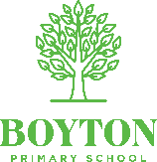 |  | Boyton Art Overview – Acorns/ Birch
 |  | Autumn 1  Civilisation and Democracy | Autumn 2  Culture | Spring 1  All Around the World | Spring 2  Exploration and Discoveries | Summer 1  Natural Wonder | Summer 2  Community
EYFS |  | What and who’s around me? | What’s that sound? | How do things change? | How do we get there? | How does it grow? | What’s over there?
 |  | -Use a range of small tools, including scissors, paint brushes and cutlery  -Safely use and explore a variety of materials, tools and techniques, experimenting with colour, design, texture, form, and function  -Share their creations, explaining the process they have used  -Be confident to try new activities and show independence, resilience and perseverance in the face of challenge |  | -Use a range of small tools, including scissors, paint brushes and cutlery  -Safely use and explore a variety of materials, tools and techniques, experimenting with colour, design, texture, form, and function  -Share their creations, explaining the process they have used  -Be confident to try new activities and show independence, resilience and perseverance in the face of challenge |  | -Be confident to try new activities and show independence, resilience and perseverance in the face of challenge;  -Work and play cooperatively and take turns with others;  -Use a range of small tools, including scissors, paint brushes and cutlery;  -Safely use and explore a variety of materials, tools and techniques, experimenting with colour, design, texture, form, and function;  -Share their creations, explaining the process they have used;
Year A | Area of focus | Drawing and sketchbooks |  | Paint, Surface, Texture |  | Working in three dimensions
Year A | Unit | Explore and  Draw  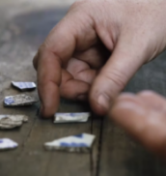 |  | Exploring Watercolour  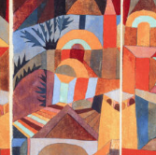 |  | Making birds  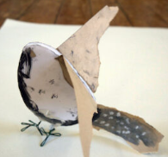
Year A | Unit | Introducing the idea that artists can be collectors & explorers as they develop drawing and composition skills. |  | Exploring watercolour and discovering we can use accidental marks to help us make art |  | Sculptural project beginning with making drawings from observation, exploring media, and transforming the drawings from 2D to 3D to make a bird
 | Artists studied | Rosie James, Alice Fox |  | Paul Klee, Emma Burleigh |  | Andrea Butler, Cailind rc Brown and Wayne Garrett, Dev Harlan
Year B | Area of focus | Paint, Surface, Texture |  | Paint, Colour, Collage |  | Collaboration and community
Year B | Unit | Expressive  Painting  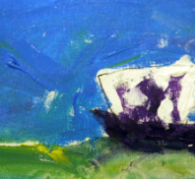 |  | Simple Print-making  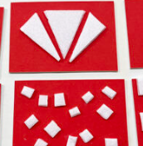 |  | Inspired by Fauna and Flora  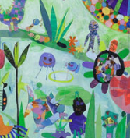
Year B | Unit | Explore how painters sometimes use paint in an expressive and gestural way. Explore colour  mixing and experimental mark making to create abstract still lifes. |  | Explore simple ways to make a print. Use line, shape, colour and texture to explore pattern, sequencing and symmetry |  | Explore how artists make art inspired by flora and fauna. Make collages of MiniBeasts and display as a shared artwork
 | Artists studied | Marela Zacarías, Charlie French, Vincent Van Gogh, Cezanne |  | Delita Martin, Karen Leder, Favianna Rodriguez |  | Eric Carle, Joseph Redoute, Jan Van Kessel

 |  | Boyton Art Overview – Chestnuts
 |  | Autumn 1  Civilisation and Democracy | Autumn 2  Culture | Spring 1  All Around the World | Spring 2  Exploration and Discoveries | Summer 1  Natural Wonder | Summer 2  Community
Year A | Area of focus | Drawing and sketchbooks |  | Paint, Colour, Collage |  | Working in Three Dimensions
Year A | Unit | Gestural Drawing with Charcoal  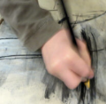 |  | Exploring Pattern  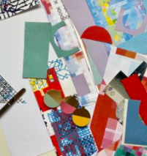 |  | Telling stories through drawings and making  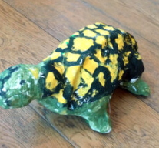
Year A | Unit | Making loose, gestural drawings with charcoal, and exploring drama and  performance. |  | Exploring how we can use colour, line and shape to create patterns, including repeating patterns.(link to Ancient Greeks) |  | Explore how artists are inspired by other  art forms – in this case how we make sculpture inspired by literature and film.
 | Artists studied | Heather Hansen, Laura McKendry, Edgar Degas |  | Rachel Parker, Shaheen Ahmed, Andy Gilmore, Louise Despont |  | Rosie Hurley, Inbal Leitner, Roald Dahl, Quentin Blake
Year B | Area of focus | Paint, Surface Texture |  | Paint, Colour, Collage |  | Collaboration and Community
Year B |  | Exploring Identity  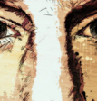 |  | Making Monotypes  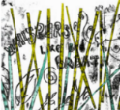 |  | Using natural materials to make images  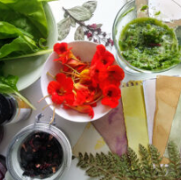
Year B |  | Discover how artists use layers and juxtaposition to create artwork which explores identity. Make your own layered portrait. |  | Explore how artists use the monotype process to make imagery. Combine the monotype process with painting and collage to make visual poetry zines |  | Using natural pigments and dyes from the local environment to make art. Exploring Cyanotype and Anthotype
 | Artists studied | Njideka Akunyili Crosby, Yinka Shonibare, Thandiwe Muriu, Mike Barrett |  | Kevork Mourad |  | Frances Hatch, Anna Atkins
Year C | Area of focus | Painting, Drawing, Collage, Sketchbooks, Relief |  | Paint, surface, texture |  | Sculpture, Painting, Drawing, Collage, Sketchbooks
Year C |  | Exploring Still life  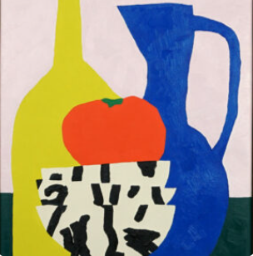 |  | Cloth, Thread, Paint  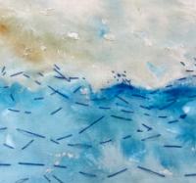 |  | Festival treats  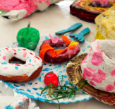
Year C |  | Explore artists working with the genre of still life, contemporary and more traditional. |  | Explore how artists combine media to create work in response to landscape. Use acrylic and thread to make a painted and stitched piece |  | Drawing and Making inspired by food. How might we use food and art to bring us together?
 | Artists studied | Paul Cezanne, Peter Claesz, Melchior d’ Hondecoeter, Jan Davidsz, Jacob Vosmaer, Hilary Pecis, Nicole Dyer, Baas Meeuws, Hirasho Sato |  | Alice Kettle, Hannah Rae |  | Claes Oldenberg, Lucia Hierro, Nicole Dyer
Year D | Area of focus | Collaboration and community |  | Paint, Colour, Collage |  | Working in Three Dimensions
Year D |  | Mixed Media Land and CityScapes  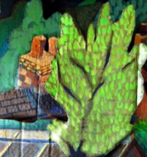 |  | Activism  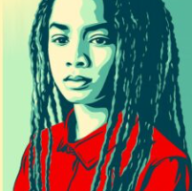 |  | Architecture: Dream Big or Small  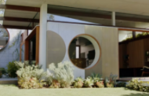
Year D |  | Explore how artists use a variety of media to  capture spirit of the place. |  | Explore how artists use their skills to speak on behalf of communities. Make art about things you care about |  | Explore the responsibilities architects have to design us a better world. Make your own architectural model
 | Artists studied | Vanessa Gardiner, Shoreditch Sketcher, Kittie Jones |  | Luba Lukova, Faith Ringgold, Shepard Fairey |  | Shoreditch Sketcher, Various Architects

