Element  Making a Mark- Form a variety of marks, shapes and letters with meaning. | Resources | What children may do | Adult Enablement + Pedagogy
Element 4 | Thin pencils  Whiteboard pens  Cotton buds with paint  Paper with lines on  Various paper for CI use | Create phonetically readable signs and communicate messages within their play which they have full ownership over. E.g. this is a sign that says ‘be careful of my special model.’  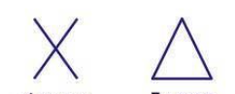  My drawings will be created using refined pre writing shapes including triangles, squares and crosses (small to large).  Form letters which sit on the line with clear ascenders and descenders. | Opportunities to read and see adults writing a range of texts such as  Stories, instructions, poems, diagrams.
Element 3 | Thin chalks  Variety of brushes  Thin Felt tips | Imaginative writing in my play. E.g.’ this is a list of all the animals that have to come into the vets.’ – This will be using the phonics sounds that I have learnt including ‘special friends’  My letters will be beginning to be consistent in size and go from left to write across the page.  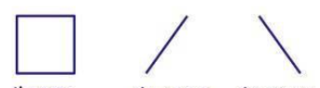  My drawings will grow in detail with clear intentions for what I am drawing. E.g. .I’m doing zig zags for the waves because it is a storm at sea.’  When I am involved in my play, I will create signs and labels to communicate my thoughts and ideas. E.g. ‘stop’ when creating a road outdoors or ‘toy shop’. | Supportive feedback on my drawings and how to improve them. E.g. I can see roofs have 3 corners. How could you make your corners pointier?’  Opportunities to read and see adults writing a range of texts such as  Labels, captions, signs and lists.
Element 2 | Playground size chalks  Large spaces  Felt tips  Short and long pencils, pens and brushes. | I will use my shoulders and arms when creating large crosses, circles and square marks with ribbons, chalk, wet paintbrushes etc.  Imaginative emergent mark making in my play. E.g.’ this is a list of all the animals that have to come into the vets.’  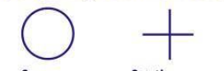  I will be forming some letters I have been learning within my ‘writing’ as I play imaginatively.  Copy circles and crosses using ribbons, large- Hand eye coordination is being utilised.  Children will talk about their intentions or outcome when they draw. E.g. this is my daddy. He has short hair.’  Stick figure drawings will be represented with the drawing shapes l, ---- and O | Adult modelling of ‘being a writer’ within role plays and for different purposes. E.g. writing a lists of the children who are school dinners or role playing a birthday party and creating ‘invitations’.  Large scale mark making development opportunities e.g. dancing to music with ribbons and ‘drawing shapes’.
Element 1 | Paintbrushes, sugar paper and baby oil  Mark examples  Paper on vertical surfaces/walls  Gloop (cornflour)  Wide variety of mark making implements  Such as; sponges, sticks, brushes, giant chalks  Pens/paintbrushes on sticks- long. | Stretch their arms up and lower them down along long strips of vertical paper in order to make marks  Explore different resources and comment on the marks they make and the process involved. ‘This is a zig zag line. It’s a rocket to the moon.’  Copy vertical and horizontal marks using ribbons, large- Hand eye coordination is being utilised.  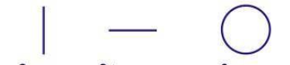 | Adults talking about the marks they make and the things they are writing about.  Large scale mark making development opportunities e.g. dancing to music with ribbons and ‘drawing shapes’.  Early exposure to print with discussions of the meaning.

