Element  Boyton Plan it! I will plan, do and review my own play ideas | Resources | What children may do | Adult Enablement + Pedagogy
Element 4 | Individual planning sheets such as ‘Play Projects’ or ‘model making plans’  Ensure resources give children the chance to make choices and plan for specific purposes e.g. a range of paintbrushes will allow them to plan for which brush is best for a thin line.  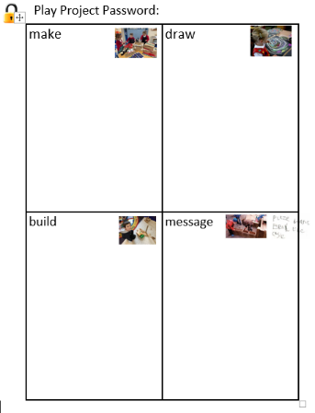 | Drawing, listing revisiting my play plans and explaining them to people I play with.  Referring back to my plans/ideas and checking to see if I have included all of my/my group’s ideas.  Referring back to my drawn plans/lists and commenting on how they went- making plans for how to improve them.  Trialling ideas and commenting on how successful they were in comparison with others’ I have made.  Making plans and commenting on what I can achieve in a set amount of time. E.g. spot timer or sand timer’- Simple Time Management.  Using photos/models of my work to support me to re plan/review/adapt my learning.  Organisation- I will draw/list the items I will need for my play and review this.  Commenting on how things turned out and why they worked/didn’t work. | Use open ended questions to support children to think of why or how things happen/work/don’t work.  Use spot timers to support children to manage their time and plans.  Model how to create ‘play projects’ with children, continue to review and adapt these in play.  Use focussed sessions to support children’s plan/do/review approaches.
Element 3 | Larger planning sheets for groups to access in provision  Images to support thinking e.g. pictures of buildings to discuss whilst planning  Ipods to take photos of my learning  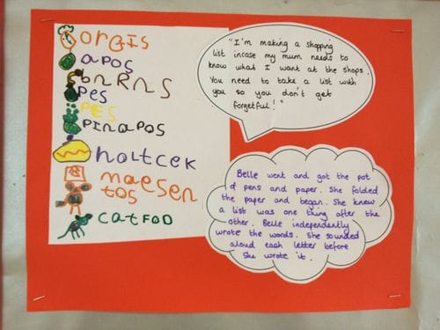 | Working collaboratively with peers to plan a play project. Adding my own thoughts which related to a group idea. Sustaining the narrative of the play verbally.  Persevering with trickier parts of my own plans.  Talking/commenting on how things went and how I will try it again/adapt.  Commenting on what I need to do ‘now’ and ‘next. (Sequencing my plan)  Using photos of my work as a stimulus for comments on my ideas. ‘This worked well because…’  My plans will have purpose in my/group play. E.g. I’m making a sign to say the vets are closed. Then the people will know not to come in.’  I will draw/list what I need for my play ideas. | Modelling and scaffolding sustained shared thinking when creating group plans.  Introduce words such as ‘persevere/problem/change’  Use prompts, thinking out loud and modelling being a learner to support children to sustain focus on their plans.  Scaffold children’s ideas using ‘now’ and ‘next’ boards.  Model how to draw ideas on planning sheets and comment on what you will need and do.
Element 2 | Large paper for shared and collaborative planning  Now and Next Boards  Choosing boards | Deciding and selecting what I will need for my own play ideas  Contributing my comments and ideas to group play plans  With scaffolding, I can comment on what I will need for my own plans.  Organising my thoughts when playing with others. E.g. I can sit here on the bus and you can sit there.’  Trying again if something fails- resilience. E.g. my building falls down.  Choosing what resource I need for the next part of my play. | Use sustained shared thinking to model the process of being involved with a ‘group plan’.  Support children with spot timers and now and next boards to scaffold shifts in attention span.  Use drawings and visuals to support children to persevere/sustain their ideas within ‘planning groups’  Model growth mind-set when things fail e.g. ‘I will try again.’
Element 1 | Real objects of familiarity  Objects children can ‘pretend’ and imagine with e.g. building blocks or loose parts. | Commenting out loud on my own play and the play of others  Organising my thoughts when I play e.g. I am going to sit here. I am the driver. This is the steering wheel’  Initiating my own play choices within the provision.  Choosing between two play objects offered to me. | Model commenting on your own play actions/resources/processes.  Comment and narrate the play of children  Use choosing boards to support simple choices for play. Use real objects to support this.

