Element  Boyton Move it! - Travel on, balance on and jump off of my own obstacle course | Resources | What children may do | Adult Enablement + Pedagogy
Element  5 | Provide benches, planks and crates for children to balance, travel and jump off of.  Add rubber spots or markers for children to travel between  Jump on and balance on.  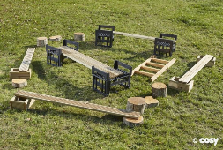  Cones  Hoops | 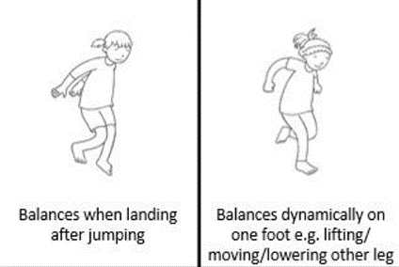  Balancing with good control in a range of environments and body positions. E.g. obstacle courses, gymnastic equipment.  Explore staying balanced with good core strength to hold body upright when jumping from: 2 to 1 foot.  Walking ‘like a gymnast’: extend core, legs, hold extended arms above shoulder height in front, up high, out to side, stress the extension of hands and fingers.  Jumping with correct landing posture off of raised equipment.  I explore skipping (step forward and hop on that foot, repeat with other foot).  Explore staying balanced with good core strength to hold body upright when jumping from: 1 to other foot, 1 to same foot.  - Walk backwards steadily toe to heel.  - As below but performed on raise surfaces that are part of my own obstacle courses.  A mature cross lateral running pattern should be present – arms and legs on opposite sides are working together | Early Movers — Activities- website link.  Model how to link balances, jumps and travel together whilst on obstacles.
Element 4 | Rubber floor spots, crates and planks in outdoors.  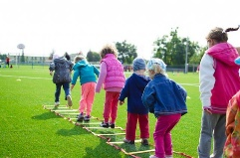  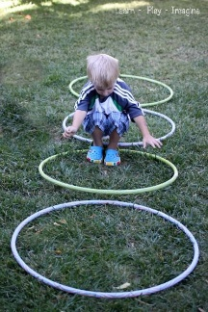  Hopscotch markings to support jumping from 1 foot to 2 and 2 feet to 1. | 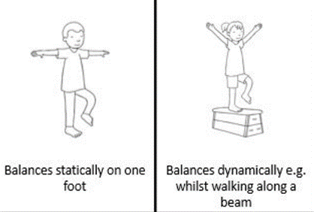  Developing steadiness when moving the body in all different directions and over different surfaces.  Explore staying balanced with good core strength to hold body upright when jumping from: 2 to 2 feet, 2 to 1 foot  Explore side stepping, bringing feet together after each side step.  Joining outdoor resources to create obstacle courses I can travel around.  Walk along a line with a beanbag on my head.  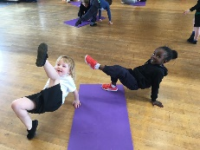  - Squat with complete steadiness and rise without support.  - Be able to remain still and hold a shape like a statue for a few seconds.  Exploring holding balances on 2 points in more dynamic ways.  - Moving own body through the environment showing an appreciation of own size and position. Able to turn, stop and start.  - Jumping from spot/area/ to another. | Model how to play games such as musical statues to support children to hold balances for longer periods of time.  Play ‘pause and hold balance’ games.
Element 3 | 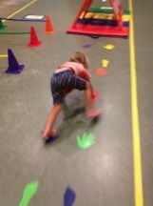  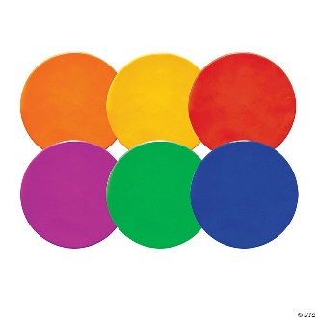 | 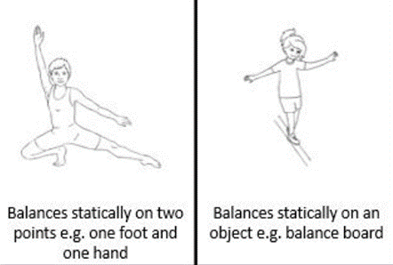  Jumping on flat ground-Correct landing position: land on balls of foot, lower heels to floor, soft knees.  - Walk along a balance board or beam.  - Walk easily along a narrow line on the floor.  - Sit with legs crossed.  Run and stop and start easily | Provide as much outdoor time as possible for children to become spatially aware of their surroundings.
Element 2 | 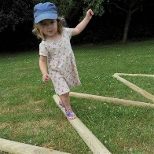 | 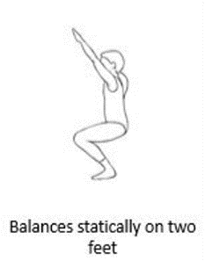  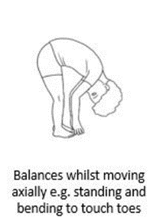  Sliding along a bench pulling body forward with both hands.  Crawling along a bench.  Balance on the ground and on wide platforms on 2 feet. E.g. musical statues.  Crawling under, around and through objects and obstacles showing a growing appreciation of their own size in relation to the space of the environment. | Model through exciting games such as ‘slide likes snakes’.
Element 1 | - Tyres to squat next to  - Wheelie items to push and develop core strength | Squat with complete steadiness and rise without support.  - Momentarily balance on one foot.  - Walk along a plank on the floor with support/independently. | Model ‘copy me’ games to support these skills.

