Element  Boyton Let’s Play a Game! Create and play a game with peers with rules. | Resources | What children may do | Adult Enablement + Pedagogy
Element 4 | Dice  Bowling pins/cans  Boards to record scores on  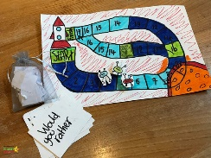  Timers  Counters  Cardboard to draw board game on  Noughts and Crosses | Use my experience of a range of games to create a game with rules, fairness and resources with my peers.  Playing games with peers with more complex multi-step rules and score keeping.  Compromising and solving conflict using resources like timers or making lists when wanting to have a go on the bikes or ball.  Playing games which support more complex Decision Making such as ‘Noughts and Crosses’ or ‘Connect 4’ | Model how to create games with rules and fairness using counters, boards, cubes and resources within the setting.  Model how to refer back to rules during the game and review where you are in the process.  Play project: sustained shared thinking about how to make, draw, build and write for their game.
Element 3 | 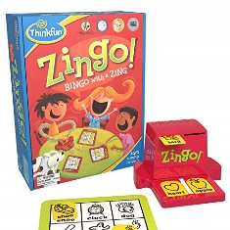  Dice, Dominoes  Board games such as snakes and ladders, Twister, Connect 4  Go Fish, Uno, Dobble, Bingo  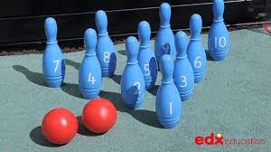  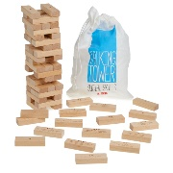  Outdoor games- bowling, hoops and beanbags  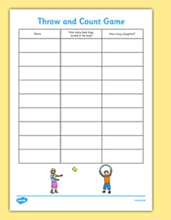  Score sheets  Decision making games such as Kerplunk, Jenga  Guess Who | Children will communicate rules of games to peers and follow them through without much adult scaffolding.  Children will begin to communicate how they are doing in a game e.g. ‘I have 2 points and Laura has 3. She’s winning.’  Children will take turns in games where they make decisions such as ‘Jenga’ or ‘Dominoes’.  Children will trial different ways to keep a record of their scores such as pre provided sheets of a table on a chalkboard.  Children will begin to make up rules in their own play e.g. rules for using items in the role play. | Heavy modelling for how to carry out the process of games, make decisions, take turns and listen to others.  Model how to record points on a sheet or board e.g, dots or tally marks.
Element 2 | 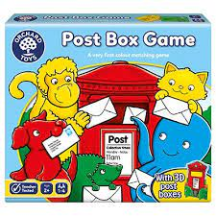  The Shopping List Game  The Tummy Ache Game  Snap  Matching Pairs  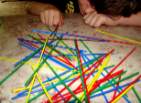  Elefun/Pop up pirate/ Hungry hippos/Crocodile teeth/Monkey business/Marble run/picture dominoes  Pick Up Sticks Game | Children will play games with 1-2 step processes. They will take turns with peers and engage in the modelled process of playing that game.  Children will carry out turn taking games with more sustained focus.  Children will point out rules of the setting to others and comment on those rules when they carry them out e.g. only use scissors in the creative area. | Heavy modelling and scaffolded support to help children to tune in to when it is their go. E.g. James, it is your go now. Hannah’s go is next.’  Model and highlight rules in the setting to children.
Element 1 | 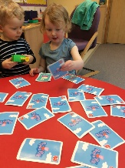  Simple memory games and turn taking equipment e.g. balls outdoors, muscial. statues.  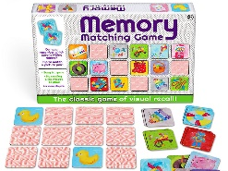  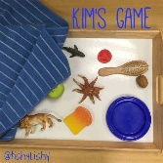 | Children will begin to tune into how a simple game is carried out with an adult or very small group. They may need support to recognise when their go is e.g. with name prompts of action.  Children will draw upon their ‘matching skills’ to make connections between what they see in simple games. E.g. 2 pictures that are the same.  Children will engage in activities with 1 peer where they ‘take turns’ to stack bricks or add parts to a puzzle. | Adults model and provide games where children can see what tuning into their ‘go’ looks like.  Support children to tune into their turn by saying their name or giving a clear prompt.

