Element  Build it! Build structures using reasoning to choose my resources | Resources | What children may do | Adult Enablement + Pedagogy
Element 6 | 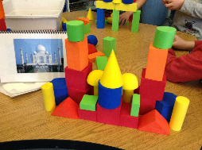  a range of 3D and 2D shapes  photos of more intricate buildings  and structures | Staircases or sloping roofs.  Structures which contain moveable features such as windows which open and close.  I will know which resources suit the job. E.g. large bricks are needed at the bottom so it doesn’t get wobbly.  Creating Multi-layered or multi part structures.  Exploring symmetry in my designs. Making symmetrical buildings.  I will test my design. E.g. Is it strong enough hold up an object?
Element 5 | Lego pieces  Range of brick and block sizes  Loose parts to add such as conkers, milk lids  2D shapes  Lolly sticks, logs, twigs  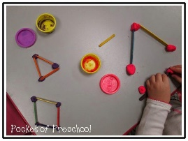 | Add other items to the model as ‘features’ or representations of their ideas.  Pre-planning my ideas with peers- ‘We will need four windows’ or ‘We to stack crates to make it tall enough for a giant to walk under.’  I will use the pincer grasp to connect smaller pieces of construction materials together such as Lego or Kinnex.  Explore and comment on pattern in my designs based on the materials I use.  Choosing bricks for exact specifications e.g. I need a tall cylinder for the trees.  3D and 2D construction pieces are chosen for their properties. E.g. using 3 equal sticks to create a triangle.  Using photos which can be interpreted and used choose what I need to build them.
Element 4 | Big crates  Magnetic Tiles  Decking lengths  3D shapes- cuboids | Making informed choices about which block, brick or piece will fill a gap. E.g. finding a cubes  Outdoors I will move crates and planks around to replicate the techniques I know on a larger scale.  I will explore how 2D and 3D shapes can be used to create simple models, commenting on my ideas as I try each shape out.  I will become more resourceful in what I add, combining resources such as planks, tarpaulin and tyres.  The models I create take on the look of what they are. E.g. adding wheels or windows or a chimney.
Element 3 | Medium bricks and blocks  Duplo  Train track pieces | Imagining what the bricks are for. E.g. if a child has created a line of bricks they may say ‘These bricks are for my road.’  Varying from using multi fingers to a pincer grasp to pick up and arrange smaller resources.  I will begin to work with others to carry crates and planks around outdoors to arrange.  Models and building with ‘flat roofs.’  Creating simple bridges by resting a block across two others. These may be used as windows of doors in my model.  Creating ‘enclosures’ around other blocks or items whilst imagining play. E.g. creating a garage or house.  Creating ‘connections’ with resources that connect such as train tracks.
Element 2 | 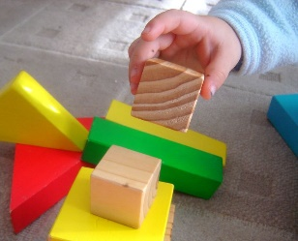  Large uniform sized bricks  Coloured Wooden blocks  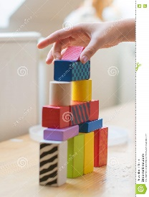  Duplo | Placing bricks in lines and towers with each brick connected.  Arranging objects into groups or lines or even in more organic arrangements.  Picking up different sized bricks using multiple fingers.  Connecting Duplo pieces together using pushing and grasping.  Building structures and talking about what I am doing but without an intention.
Element 1 | Pebbles, shells  3D shapes  2D shapes-cubes and cylinders  Bricks | Exploring the properties and function of building resources. E.g. these stack and these roll.  Exploring simple special awareness puzzles e.g. different sized squares or curves which can fit into one another.  Sorting and exploring building resources that are the ‘same’.

