Growing and Changing – part of our Personal Social Health and Economic Education (PSHE)
Year 4
What your child has been learning about:

This half term's PSHE topic 'Growing and Changing' incorporated Relationships and Health Education (RHE) and has been designed to cover key skills, attitudes and values children need to explore in order to develop healthy relationships with their peers. Children have also learnt how to keep themselves safe and how to ask for help when they need it.
Year 4 topics build on and reinforce the themes of the previous years. New content has covered teaching children to recognise and understand conflicting emotions. We’ve learnt how to recognise and understand good and not-so-good feelings. We also found strategies to deal with change and given examples of safe and unsafe secrets.
Other new topics we’ve been looking at include:
Body changes as they approach and move through puberty including menstruation and human reproduction
The children are now able to identify parts of the body that males and females have in common and those that are different, knowing the correct terminology for their genitalia. These lessons have ensured that the children can understand and explain why puberty happens.

Leading on from the lesson in Year 3 on menstruation, we’ve taught the children that periods are a normal part of puberty for girls and helped them identify some of the ways to cope better with periods. We also raised awareness of wet dreams and how some boys can wake up feeling sticky from releasing semen during the night. Depending on your school's RSE policy, self-touch/masturbation may have been first introduced in this topic to help children understand about appropriate and inappropriate touch within the boundaries of public and private places.

The children will now understand that babies come from the joining of an egg and sperm, but not how this occurs. They will therefore be able to explain why periods occur when an egg doesn't meet a sperm.

Marriage and partnerships
Increasing children’s understanding of what is meant by a positive, healthy and loving relationship is an important part of safeguarding their health and wellbeing. Children have looked at different kinds of relationships and the values, expectations and responsibilities within healthy, positive relationships. They understand that relationships can change over time and have explored some ways that changing relationships can be managed, ensuring behaviour is respectful, even when things do change.
Children have learnt that marriage is a commitment freely entered into by both people and can include opposite-sex and also same-sex partners. They’ve learnt the legal age for marriage and explored reasons why some adults might choose to be married, live with someone, or have a civil ceremony.

Vocabulary your child learnt:

Puberty, hormones, pubic hair, eggs, sperm, penis, testicles, breasts, ovaries, womb, vagina, vulva, clitoris, labia, menstrual cycle, periods, period pad, period pants, menstrual cup, tampon, civil partnership, forced marriage.

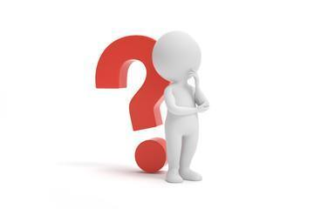
Questions your child may ask at this age:

- When were you allowed to start doing things more independently?
- Did you have to do or prove anything to gain more independence from your parents?
- What products do you use for periods?
- When I start my period, where can I get period products from?
- When did you start puberty?
- How did you feel? Was it bad?
- Is it normal?
- How can I tell someone not to do something that’s making me uncomfortable, but without hurting their feelings?
- Have you ever been made to keep a secret when you didn’t want to? How did you handle it?
- Why do some grown-ups decide to get married/have a civil partnership/live together?

Resources for Parents: SCARF Growing and Changing Parents Page




Age 6-10 | Outspoken Sex Ed Resource for Parents Stages of puberty


Outspoken Sex Ed Starting your periods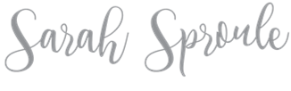
How to talk to your kids about everything RSE related
Taking Care of Your Body
Personal hygiene for pre-teens

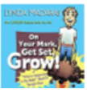
Books to support learning:
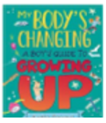
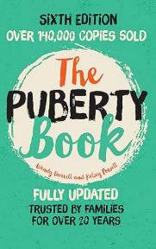
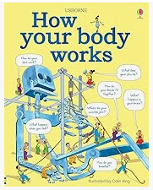

On your marks, get set, grow!

The Puberty Book
How your body works
A Boy’s Guide to Growing Up
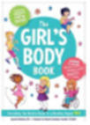
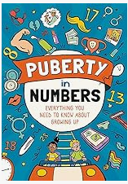
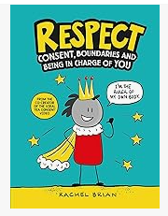
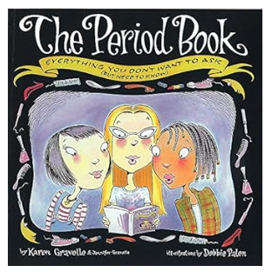

Respect
The Girl’s Body Book The Period Book Puberty in Numbers

