Growing and Changing – part of our Personal Social Health and Economic Education (PSHE)
Year 6
What your child has been learning about:

This half term's PSHE topic 'Growing and Changing' incorporated Relationships and Health Education (RHE) and has been designed to cover key skills, attitudes and values children need to explore in order to develop healthy relationships with their peers. Children have also learnt how to keep themselves safe and how to ask for help when they need it.
In Year 6, we’ve been preparing children for their transition into secondary school, where they will be mixing with and hearing things spoken about by much older children. We aimed to provide children with the right information before potentially being exposed to confusing or wrong information.
We’ve covered topics that build on and reinforce all the themes of the previous years, with new content included into the lesson plans looking at:
Body image and the media
We want the children to recognise that photos can be changed to match society's view of ‘perfect’. It’s also important that the children can identify qualities that people have, as well as how they look.
Puberty and what is 'normal'
We’ve taught the children about physical and emotional changes during puberty and where to get support if they are feeling challenged by these changes. Lessons have extended pupils’ thinking about puberty and the concept of change throughout our lives. We explored, in more detail, some of the feelings associated with change. It’s helpful for pupils to consider changes that might occur alongside puberty, including moving to secondary school and the new roles and responsibilities that might accompany this.
We’ve also taught the children about consent and understanding that nobody has the right to alter their bodies. At the end of the unit, children now understand that FGM involves cutting/altering a girl’s genitals, that it is an illegal practice in this country, and where to get support if concerned about their own or another's safety.
Sexual intercourse, conception, reproduction and birth
During these lessons, children have gained an understanding of the changes that happen in puberty to allow sexual reproduction to occur, as well as ways in which the sperm can fertilise the egg to create a baby, including sexual intercourse and assisted reproduction.
By Year 6, pupils will likely have some understanding of the fact that babies are made through sexual intercourse. Although it’s possible they may have some misconceptions, very few pupils will still believe myths or make-believe stories. Having an understanding of what is meant by sex is an important foundation for the RSHE they will receive at secondary school. The lesson about this emphasised that having sexual intercourse, and also the decision to have a baby, is something for when they are much older. It also highlighted the importance of consent in this context. It enabled pupils to reflect on values and responsibilities within healthy adult relationships.
HIV
We’ve explained how HIV affects the body’s immune system. Children now understand that HIV is difficult to transmit; helping to dispel some of the myths associated with the virus, and how a person can protect themselves from HIV.
Managing pressure online
It is vital that the children understand the risks of sharing images online and how these are hard to control once shared. It is also important to know that the frequency of risk-taking behaviour is much lower than it is believed to be.

Vocabulary your child learnt:

media manipulation, gender stereotype, right to privacy, female genital mutilation, confidential, egg, ovaries, sperm, testicles, vagina, penis, embryo, womb, surrogacy, womb, adoption, assisted reproduction, adoption, HIV, immune system, transmission, orgasm, sexual intercourse, consensual, condom.

Questions your child may ask at this age:
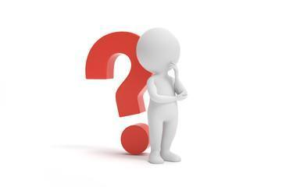
x
- When did you start your period?
- What period products should I use?
- Have you ever had a wet dream?
- What deodorant should I use?
- How old do you have to be to have sex?
- Do you have to be in love to have sex?
- What’s an erection?
- What’s an orgasm?
- Have you had sex?
- How was I conceived?
- Did you get sick when you were pregnant?
- Can you tell me about when I was born?
- What can I do to be more independent?
- Have you ever been pressured to post a silly picture online or to someone?
- Is it normal?

Resources for Parents: SCARF Growing and Changing Parents Page




Age 6-10 | Outspoken Sex Ed Resource for Parents Stages of puberty


Outspoken Sex Ed Starting your periods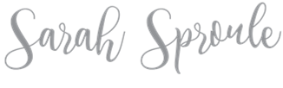
How to talk to your kids about everything RSE related
Puberty Pregnancy & Reproduction
HYPERLINK "https://www.bbc.co.uk/teach/class-clips-video/pshe-ks2-operation-ouch-how-are-babies-made-full-programme/zhtnydm" Operation Ouch:
How babies are made

Books to support learning:
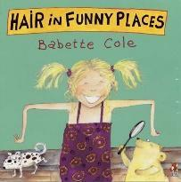
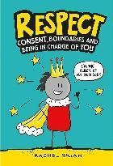
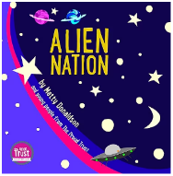
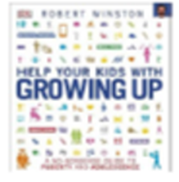

Helping your kids
with growing up Hair in Funny Places Alien Nation Respect
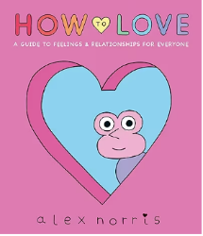
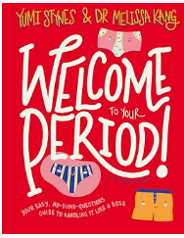
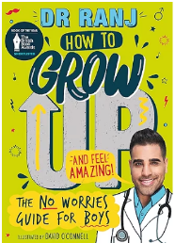
Helping your kids with growing up

How to grow up and feel amazing
How to love (11+) Welcome period
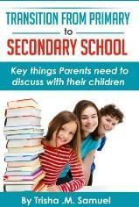
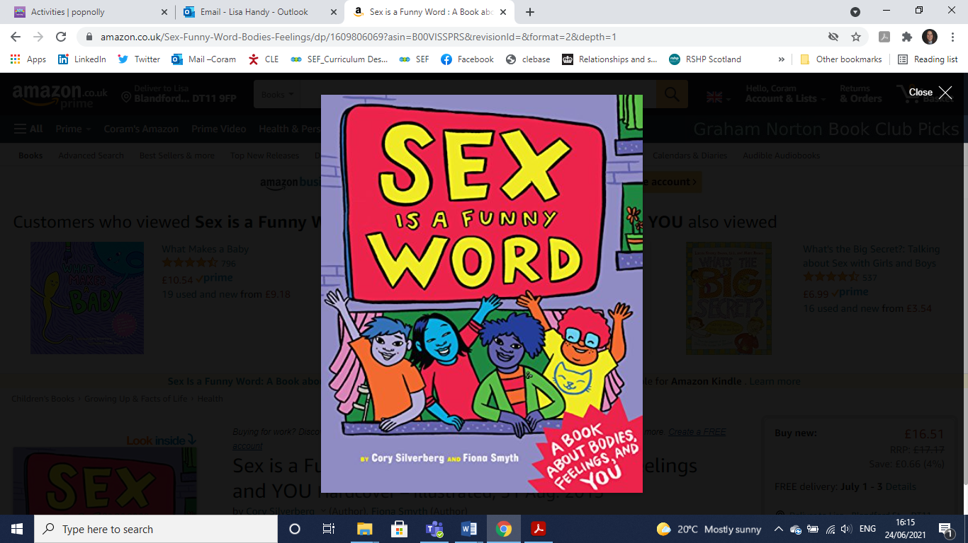
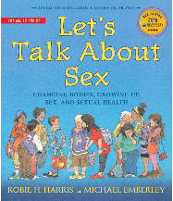

Let’s talk about sex Transition From Primary to
Secondary School

