Growing and Changing – part of our Personal Social Health and Economic Education (PSHE)
Year 5
What your child has been learning about:

This half term's PSHE topic 'Growing and Changing' incorporated Relationships and Health Education (RHE) and has been designed to cover key skills, attitudes and values children need to explore in order to develop healthy relationships with their peers. Children have also learnt how to keep themselves safe and how to ask for help when they need it.
In Year 5, this topic builds on the themes covered previously but in greater depth, looking more closely at: how children’s changing feelings during puberty and as they grow up can affect those they live with; what makes relationships unhealthy, including how individual or group actions can impact others in a positive or negative way; and exploring safe and unsafe secrets and when to break a confidence in order to keep someone safe. In this topic, we’ve helped the children to understand their emotions and identify strategies they can use to build resilience, along with strategies to deal with uncomfortable situations.
We’ve also been exploring the themes of:
Body changes and feelings during puberty
Building on the themes surrounding puberty previously covered, children will know the correct words for the external sexual organs. We’ve discussed some of the myths associated with puberty, identify some products that they may need during puberty and why. We educated the children on some changes that people experience during puberty, including menstruation and why it happens, involuntary erections, wet dreams, masturbation, body shapes changing and hair growth.
Different types of bullying including homophobic and transphobic
We’ve taught the children that any form of bullying is unacceptable, including bullying based on how someone expresses their gender or sexual orientation. We helped children to have more awareness of bullying behaviours and give examples of how they can be stopped.

Vocabulary your child learnt:

separation, fostered, pubic hair, clitoris, vulva, vaginal opening, urinary opening, lips (labia), penis, scrotum, testicles, foreskin, anus, wet dreams, erection, stretch marks, puberty, semen, menstruation, masturbation, reactions, hormones, compromise, prejudice, sexual orientation, gender identity.

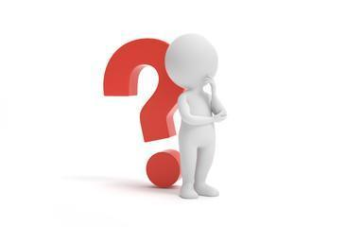
Questions your child may ask at this age:

- When did you start puberty?
- How did you feel? Was it bad?
- Is it normal?
- How can I tell someone not to do something that’s making me uncomfortable, but without hurting their feelings?
- Have you ever been bullied or know someone who was bullied? What did you do?
- Have you ever been treated in a stereotypical way?
- Have you ever been made to keep a secret when you didn’t want to? How did you handle it?
- Do you have to shave?
- How old do you have to be to shave?
- What period products should I use?
- Do I need to wear deodorant?
- Can you help me get some things to prepare for my body changing?

Resources for Parents: SCARF Growing and Changing Parents Page




Age 6-10 | Outspoken Sex Ed Resource for Parents Stages of puberty


Outspoken Sex Ed Starting your periods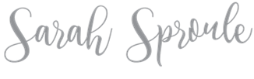
How to talk to your kids about everything RSE related
Parent Support
Personal hygiene for pre-teens


Books to support learning:
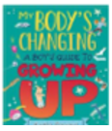
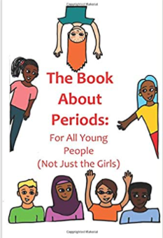
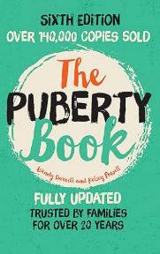

On your marks, get set, grow!

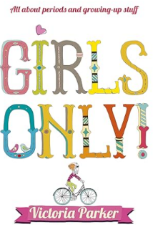
The Puberty Book
The book about periods
A Boy’s Guide to Growing Up
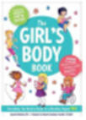
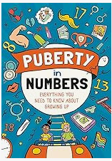
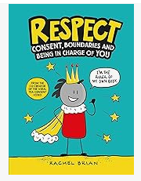

Respect
The Girl’s Body Book Girls Only! Puberty in Numbers

