Growing and Changing – part of our Personal Social Health and Economic Education (PSHE)
Year 3
What your child has been learning about:

This half term's PSHE topic 'Growing and Changing' incorporated Relationships and Health Education (RHE) and has been designed to cover key skills, attitudes and values children need to explore in order to develop healthy relationships with their peers. Children have also learnt how to keep themselves safe and how to ask for help when they need it.
Year 3 topics build on and reinforce all the themes of the previous years. New content has covered:
Healthy and unhealthy relationships
Children were asked to consider people who they think of as their ‘special people’. Children may not have wished to name a person but coud label them: friend, parent (mum/dad/carer), grandparent, aunt, neighbour, teacher etc. The children are now able to identify different types of relationships.
The focus has been on positive, healthy relationships, and asked children to consider what makes a relationship unhealthy or negative, such as breaking promises. Teachers highlighted that our ‘special’ people are those who make us feel safe and comfortable, and that should children ever feel uncomfortable or unsure about something, even with a person they know well, they should tell a different adult – someone they trust.
Menstruation
It’s essential to teach about puberty before children experience it. This helps to ensure that their physical, emotional and learning needs are met and that they have the correct information about their changing emotions, how to take care of their bodies, and understand how to keep themselves safe. NHS guidance states that girls as young as 8 can start menstruating.
These lessons have prepared the children in advance for changes they will experience and allow girls to understand that periods are a normal part of puberty. We’ve delivered the lesson on menstruation to both girls and boys, along with some of the main changes boys will experience. Learning about menstruation is a concept of reproduction covered by the National Curriculum for Science; doing this fosters good relationships by breaking down the stigma and potential fears of going through these changes. This, in turn, can help to prevent bullying.
We’ve explained both what a period is and why menstruation happens. We’ve explained that babies are created when an egg and a sperm join together, but not how they come together. We’ve explained that menstruation occurs when an egg does not join with a sperm, so the lining of the womb is no longer needed.
Body space
We’ve helped children understand what is meant by the term body/personal space, including when it’s appropriate or not appropriate to allow someone into their body space. For example, someone might be in our body space if you invite them to hug you or when playing tag with friends.
Someone might be in our body space without meaning to be e.g. on a crowded bus, or when we don’t want them to be, such as during an argument. To reinforce the learning, the children have practised being assertive and rehearsed strategies for how to manage someone in their body space without consent.
Secret or surprise
Children have been taught the difference between the terms 'secret' and 'surprise’ and to know the difference between a safe and an unsafe secret, including how these different things might make them feel. For example, a surprise party would be a safe secret that could make a child feel excited. In contrast, a friend who talks about taking a knife from a toolbox at home to school would be an unsafe secret to keep and might make the child feel uncomfortable. The class teacher discussed what to do or who they might tell if they have been told an unsafe secret or a secret that makes them feel uneasy.

Vocabulary your child learnt:

personal space, invade, respect, uncomfortable, jealous, egg, sperm, puberty, period, ovary, fallopian tube, uterus (womb), lining, vaginal, period/menstruation pad, tampon, menstrual cup.

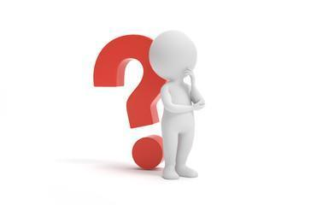
Questions your child may ask at this age:
- What can I do, without hurting someone’s feelings, if someone invades my personal space?
- Have you ever had to tell someone to stop doing something that made you feel uncomfortable?
- Can you help me practise being assertive?
- What was puberty like for you?
- When did you start your periods?
- What products do you use for periods?
- When I start my period, where can I get period products from?
- Who are your ‘special people’ that you trust? Why them?
- Can I talk to you about who my ‘special people’ are that I can go to if I want to talk or if I need help?

Resources for Parents: SCARF Growing and Changing Parents Page





Age 6-10 | Outspoken Sex Ed
Outspoken Sex Ed Resource for Parents Stages of puberty
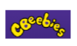
Starting your periods


Friendship Struggles Helping Your Child Make Friends at Primary School



Menstruation Help your child navigate friendship problems

Books to support learning:
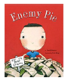
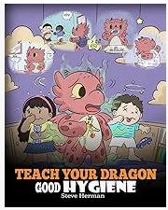
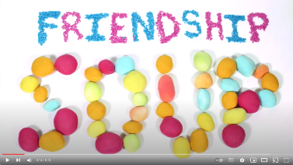

Friendship Soup
Enemy Pie
Teach your dragon good hygiene

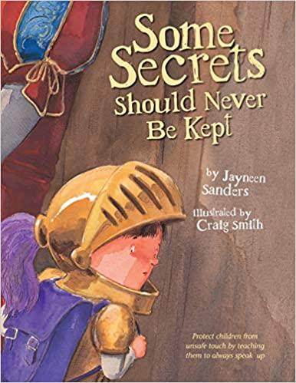
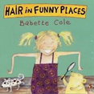
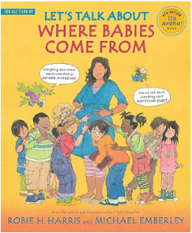

Hair in funny places
Let’s talk about where babies come from

