Growing and Changing – part of our Personal Social Health and Economic Education (PSHE)
Year Group: Nursery
What your child has been learning about:

This half term's PSHE topic 'Growing and Changing' incorporated Relationships and Health Education (RHE) and has been designed to cover key skills, attitudes and values children need to explore in order to develop healthy relationships with their peers. Children also learnt how to keep themselves safe and how to ask for help when they need it.
In the ‘Growing and Changing’ unit for Nursery, your child observied changes in seasons - its plants and animals - over time (tadpoles, caterpillars, and eggs). They also were helped to identify how they have changed as they have grown, think about what babies need and what they might want to be when they grow up.

During these lessons and activities, your child was encouraged to recognise different types of families and talk about their own families. We aimed to help children understand that although families might look different, the important thing is that all families provide love, care and security.

We also explored how girls and boys are different, recognising the gender stereotypes that exist and gently challenging any such stereotypes arising in class so that all children benefit from a rich and broad range of learning experiences, not limited by stereotypical ideas of what is appropriate for girls or for boys.

Leading on from this, your child learnt the names for the body parts using the correct vocabulary (depending on the School’s RSE policy). It is important that the children are able to identify and explain which parts of their body are kept private and safe, and why. They also learnt how to tell or ask an appropriate adult for help if they feel unsafe.

Vocabulary your child has learnt:

Seasons, growth, plants, change, weather, penis, vulva, private parts, life cycle, baby, growing up, adults, families, love, care, safety, differences.

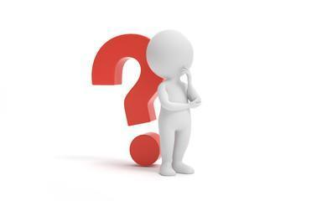
Questions your child may ask at this age:

- Why do things change?
- What parts are private?
- What do you call private body parts?
- Why are they private?
- Do you have a penis or a vulva?
- Why do some people have different families?
- What is important about families?
- Have you ever felt unsafe? Why?
- Why do people have jobs?
- What did I eat when I had no teeth?
- What did I look like when I was a baby?
- How have I changed?
- Can boys and girls do the same things?

Resources for Parents: SCARF Growing and Changing Parents Page

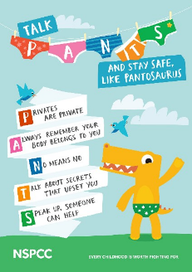

Age 2-5 | Outspoken Sex Ed A Resource for Parents
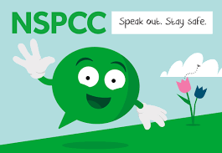
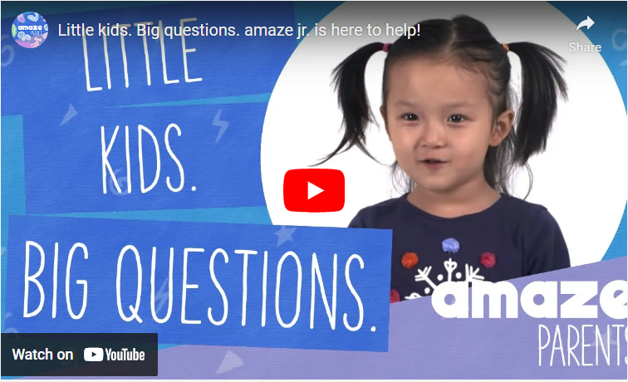
The Underwear Rule

Sexual Development in children Amaze Junior

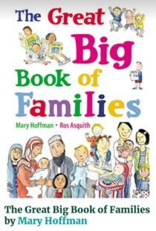
Books to support learning: The Great Big Book of
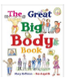
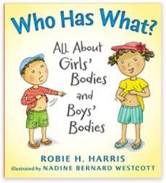
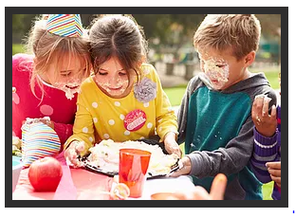
Families

Book Lists - All About Me Who Has What? The Great Big Body Book

