Growing and Changing
Year Group: Reception

What your child has been learning about:

This half term's PSHE topic 'Growing and Changing' incorporates Relationships and Health Education (RHE) and has been designed to cover key skills, attitudes and values children need to explore in order to develop healthy relationships with their peers. Children also learn how to keep themselves safe and how to ask for help when they need it.
In Reception, children learn to recognise how they have changed and know the different human life stages e.g. baby, child, teenager, adult, older age. They are able to explain that a baby is made by a man and a woman and that a baby grows inside the mother’s tummy or woman’s womb (the language used depends on the school’s RSE policy). We discuss how families are different and how we are all unique. The children will identify their similarities and differences.

The children also explore the life stages of animals and plants, using relevant vocabulary (again, the language depends on your school’s RSE policy) such as egg, seed, sperm, baby, grow, change, old, young. We also learn the names for young animals.

In Reception, we name parts of the body (including reproductive parts) using the correct vocabulary; penis and vulva (depending on your school’s RSE policy). For children to be kept safe, it’s important that they can identify and explain which parts of their body are kept private and safe and why, and to tell or ask an appropriate adult for help if they feel unsafe.

Vocabulary your child will have learnt:

seasons, life cycle, baby, child, adult, teenager, old age, private parts, penis, vulva, growing, family, love, care, safe, changes, womb.

Questions your child may ask at this age:
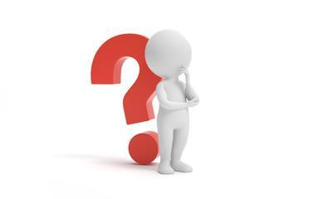
- What was I like as a baby?
- How did you look after me when I was a baby?
- Where do babies come from?
- How did I eat when I was a baby?
- Did I grow in your tummy?
- What did I do in mummy’s tummy?
- When did I come out?
- How have I changed?
- Do you have a penis or a vulva?
- Can you help me think of my ‘special people’ that I can talk to if I need help?
- Why are privates private?
- Can you help me to remember the 5 rules of our NSPCC PANTS lesson? Privates are private; Always remember your body belongs to you; NO means NO; Talk about secrets that upset you; Speak up, someone can help.

Resources for Parents: SCARF Growing and Changing parent/carer page

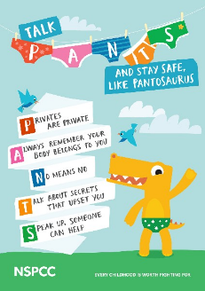

Age 2-5 | Outspoken Sex Ed A Resource for Parents
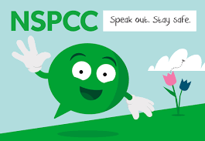
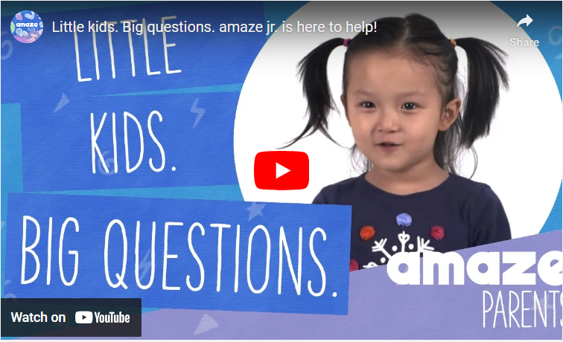
The Underwear Rule |

Sexual Development in children Amaze Junior

Books to support learning
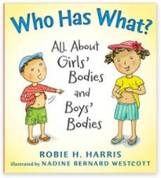
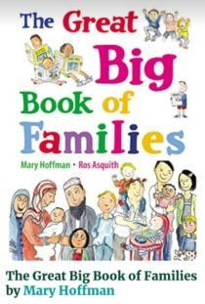
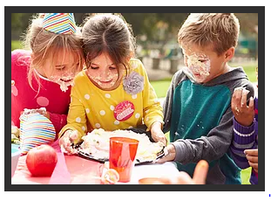
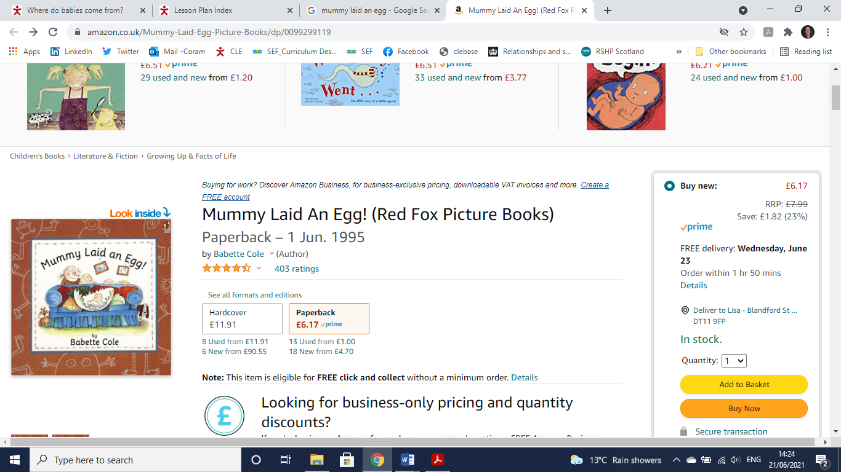

Mummy laid an egg

The Great Big Book of Families
Book Lists - All About Me Who Has What?

