Growing and Changing – part of our Personal Social Health and Economic Education (PSHE)
Year 1
What your child has been learning about:

This half term's PSHE topic 'Growing and Changing' incorporated Relationships and Health Education (RHE) and has been designed to cover key skills, attitudes and values children need to explore in order to develop healthy relationships with their peers. Children have also learnt how to keep themselves safe and how to ask for help when they need it.
In Year 1, your child has been taught to recognise that genitals are private and know their correct names. They learnt to identify people that they are able to talk to safely about these private parts of their body. They developed an understanding of the difference between surprises and secrets (good or bad secrets) and when not to keep bad adult secrets.
Through the course of these lessons, your child is also now able to identify the ways that they have changed from a baby until now and know the basic needs and tasks required to look after a baby. They are able to identify people who help/helped them during the different stages.
Your child also learnt about bullying and teasing and where to get help if they witness or experience bullying.

Vocabulary your child has learnt:

organ, intestines, digested, oxygen, attention, unkindness, teasing, bullying, witness, uncomfortable, privates, penis, vulva, hygiene.

Questions your child may ask at this age:
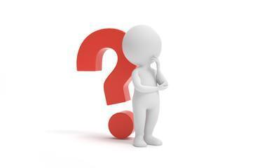
- What was I like as a baby?
- What did you do to look after me when I was a baby?
- How am I changing as I grow up?
- Do you have a vulva or a penis?
- Has anyone ever asked you to keep a secret that made you feel uncomfortable? What did you do?
- Why are some secrets not safe?
- What kinds of things are unsafe secrets?
- Have you ever been bullied?
- Have you seen someone else being bullied? What did you do?
- Can you help me think about who I can go to for help if I need it?
- What do you call private parts?
- Why are private parts private?
- Can you help me to remember the 5 rules of our NSPCC PANTS lesson? Privates are private; Always remember your body belongs to you; NO means NO; Talk about secrets that upset you; Speak up, someone can help.


Resources for parents: SCARF Growing and Changing Parents Page
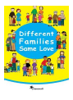


Healthy relationships | NSPCC Healthy Relationships



Age 2-5 | Outspoken Sex Ed Resource for Parents Different Families
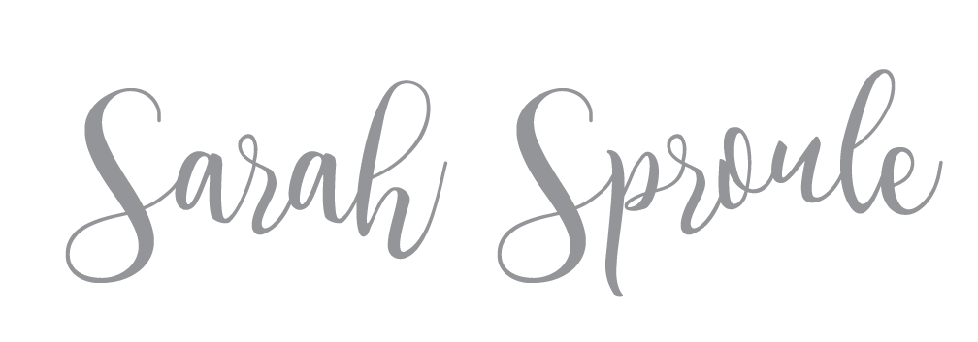
Age 6-10 | Outspoken Sex Ed
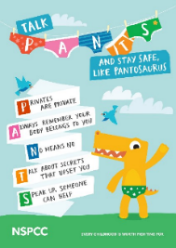

The Underwear Rule | NSPCC
How to talk to your kids about everything RSE related

Books to support learning:
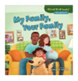
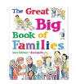
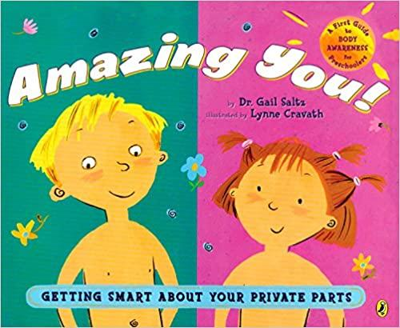

Amazing You!
My Family, Your Family The Great Big Book of Families

