 | 1 | 2 | 3 | 4
Maths | 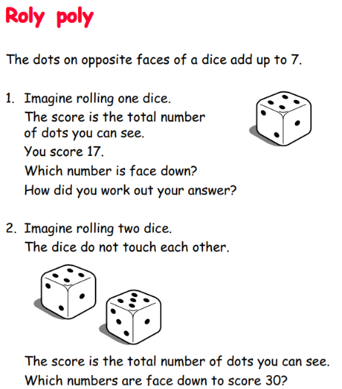 | 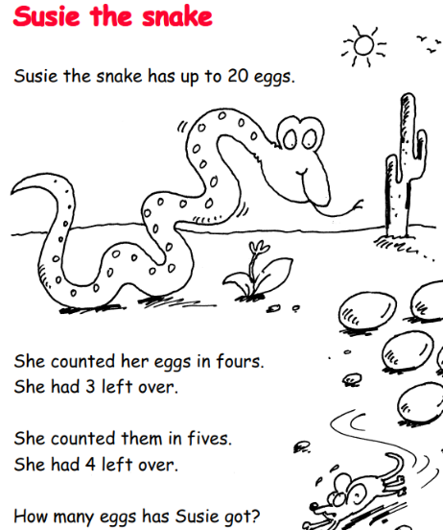 | 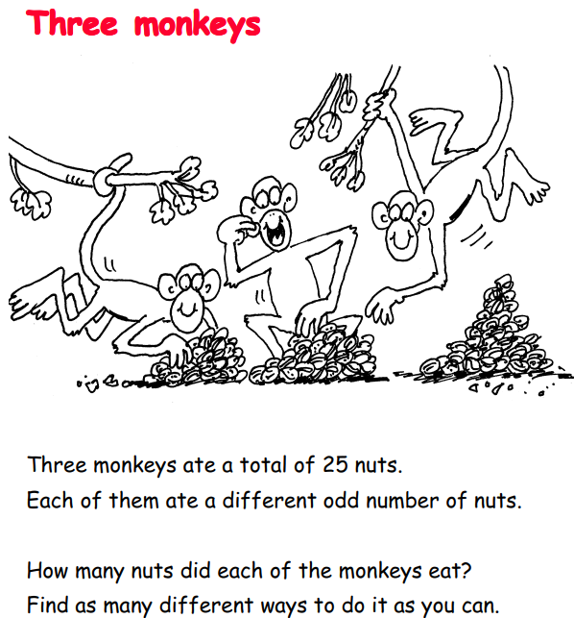 | 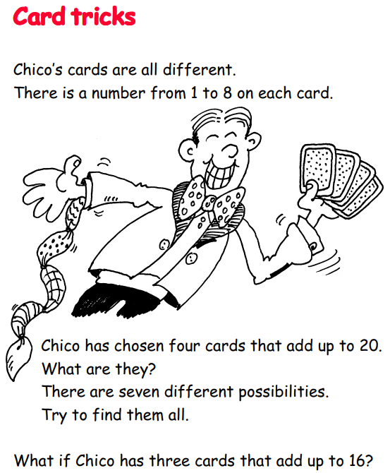
English | Spelling lists have been placed in your child’s homework book. This is the statutory list for Year Three and Four. It is suggested that your child choose between 5 and 10 spellings a week to practice at home. |   If you had one superpower, what would it be? Explain why you have chosen that superpower, what you would do with it, and how it would change your life. | 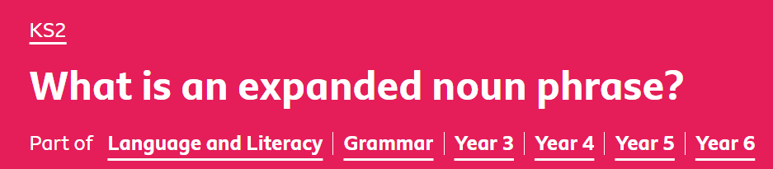  What is an expanded noun phrase? - BBC Bitesize | Describe your dream family holiday in no more than 200 words! 
Topic | Geography – research and make a volcano!  https://www.bbc.co.uk/bitesize/articles/zd9cxyc | Art – observational drawings/ paintings of plants  www.bbc.co.uk/bitesize/subjects/zxv346f | Science – and forces  Make an experiment using different vehicles and surfaces – how far can they travel on different surfaces  Forces - KS2 Science - BBC Bitesize | RE – Shabbat www.bbc.co.uk/teach/school-radio/articles/zvsj96f  Create a powerpoint or factsheet to share your findings.
In addition to daily reading, please complete one of the English or Maths activities each week (they can be done in any order). Please choose at least one of the topic activities to complete over the next 4 weeks. Learning can be recorded in any format in addition to your home learning book (e.g photos, models etc). Please can home learning be handed in on Wednesdays, I will then feedback and return on Thursday. Thank you!

