Boyton Primary School – Chestnuts learning
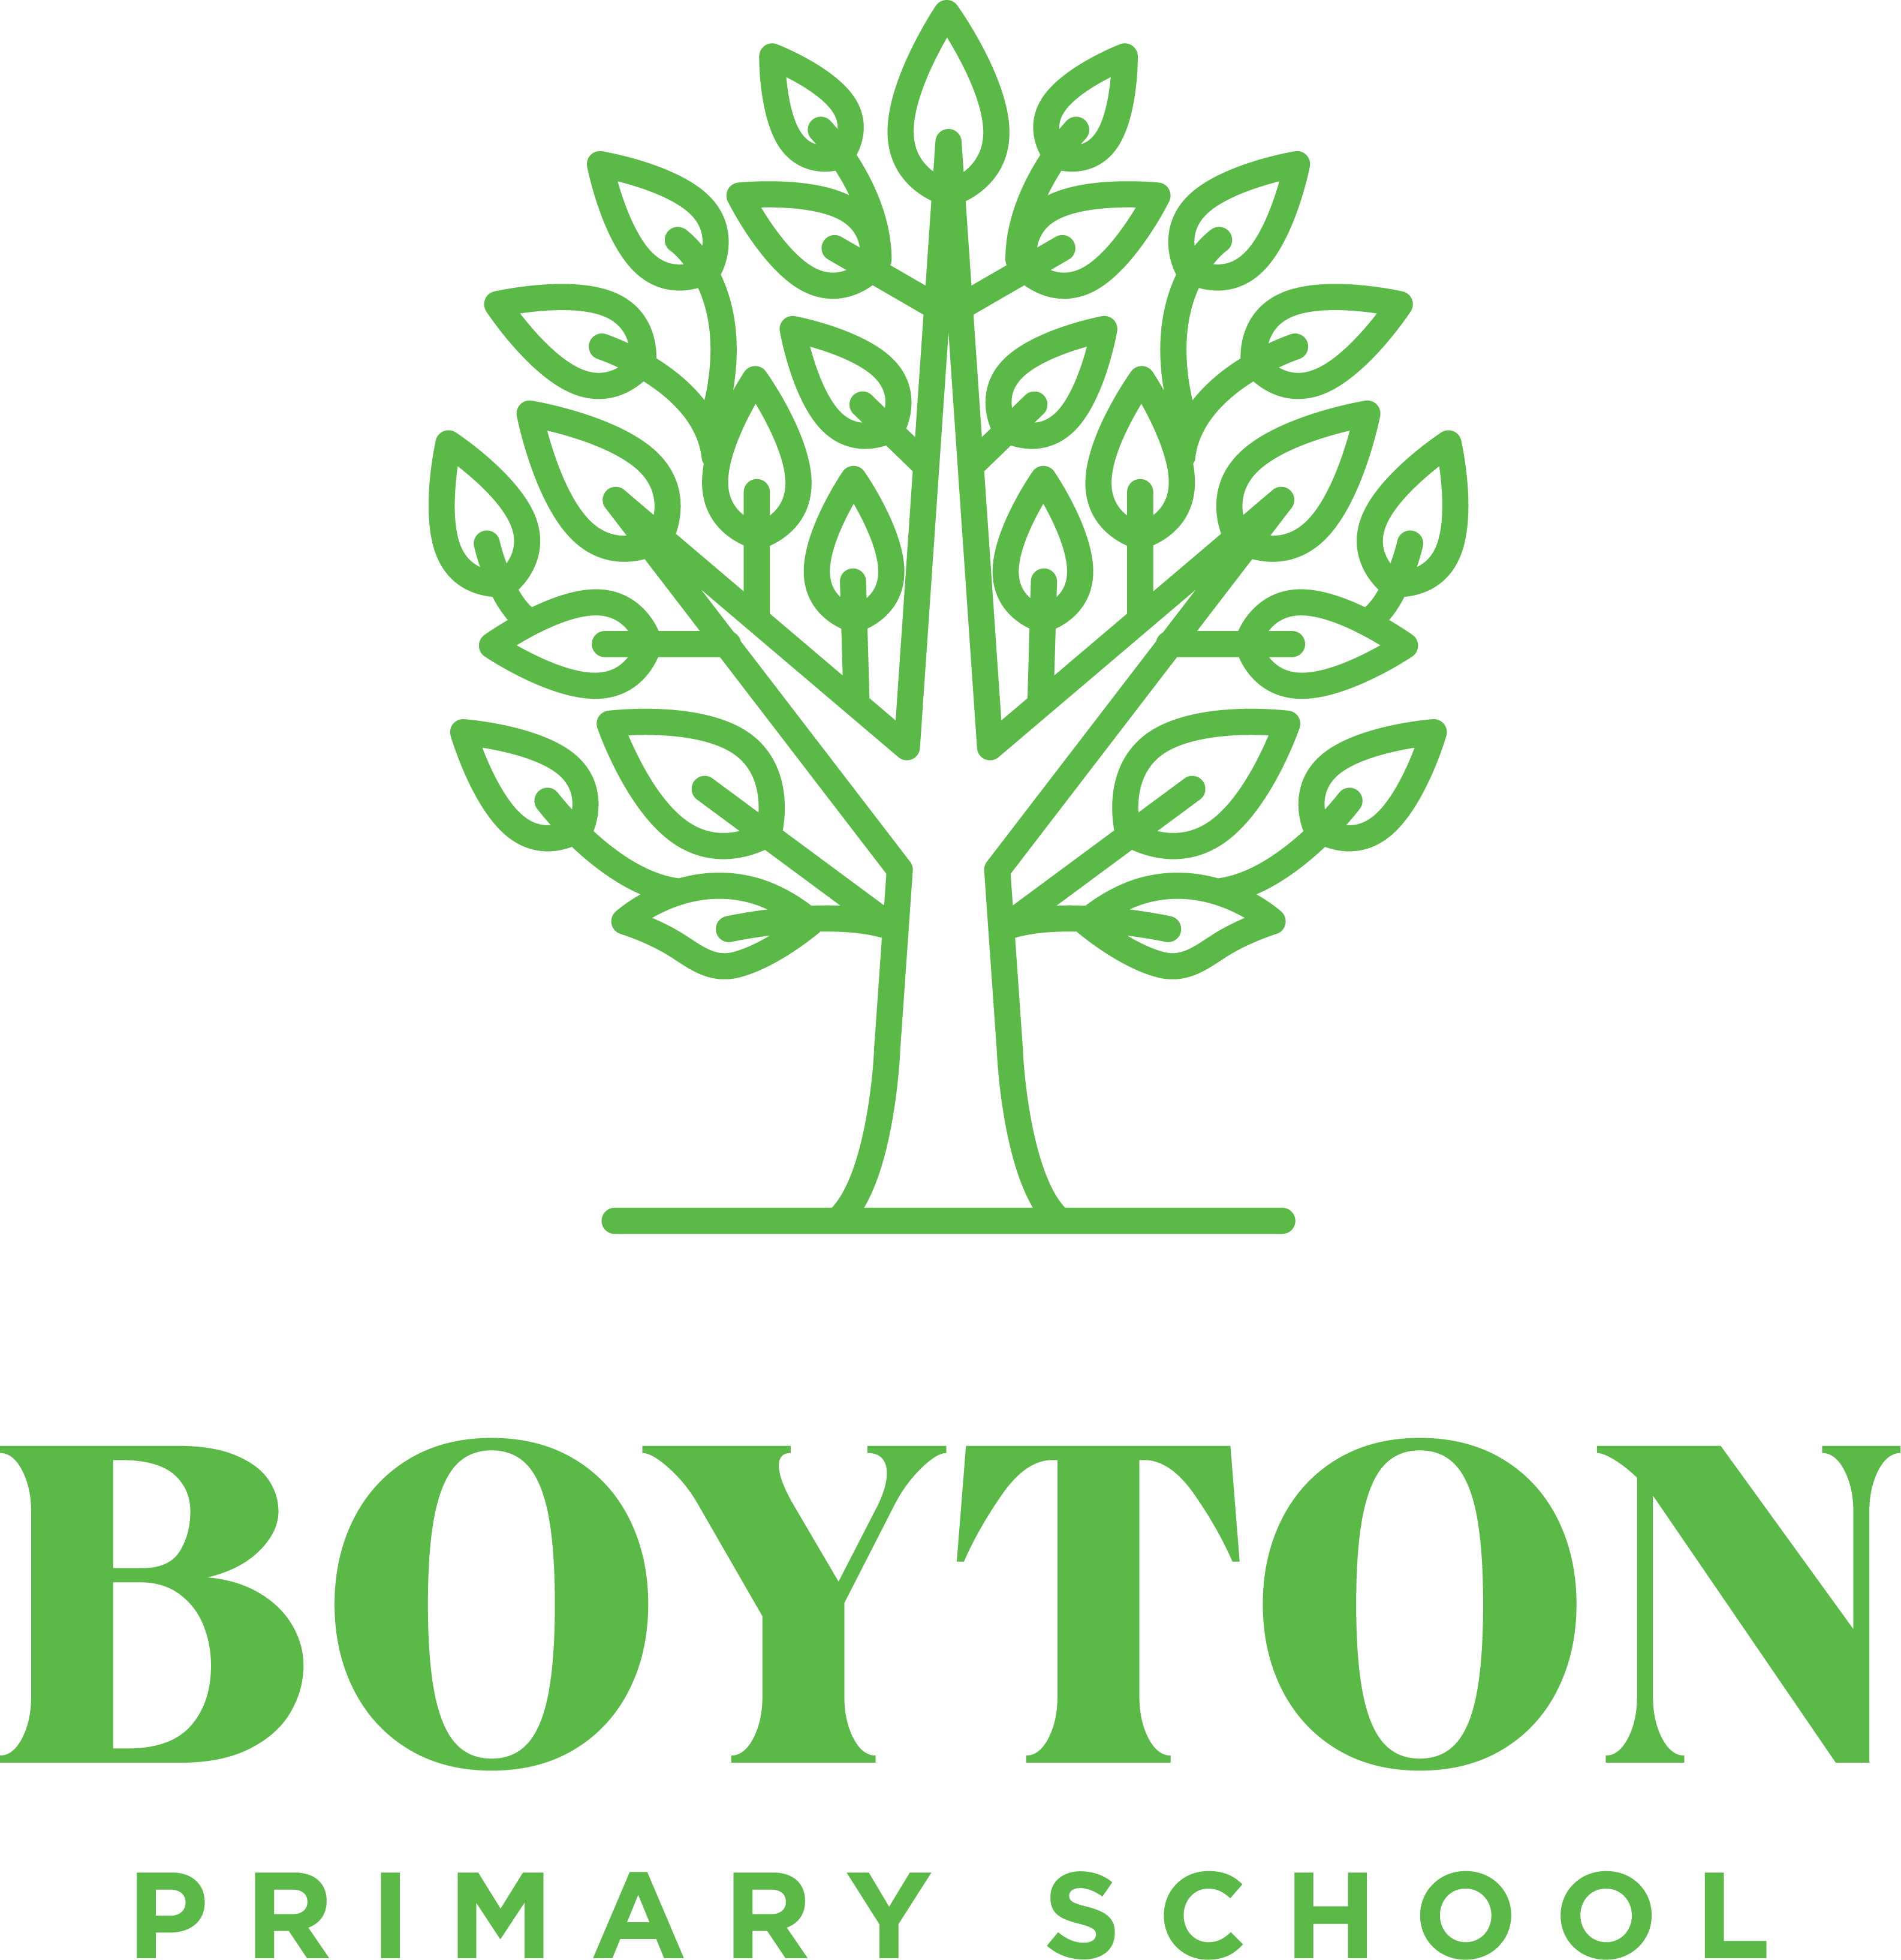
Spring Term 2025
This term, we have some great areas of learning. Please encourage your child to share any research they may do at home. For more detail, check the curriculum resources on the school website.
Writing  Film pitches Reported speeches, speech and thought bubbles, descriptions, recounts in role, letters to a newspaper editor  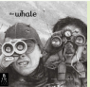  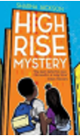  Extended stories, Character & setting descriptions, police & newspaper report, dialogue, persuasive letters  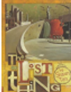  Own version narratives, Diaries, formal letters, adverts, character and setting, descriptions, reports  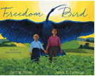  https://www.bbc.co.uk/bitesize/subjects/zv48q6f  Biographies, Non-narrative, poems, explanations, dialogue, postcards, letters of advice, descriptions, recounts, narrative | Reading – developing reading fluency, extending vocabulary and developing skills in prediction, retrieval, explanation, summary, sequence, inference.  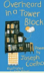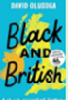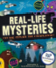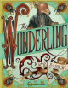  https://www.bbc.co.uk/bitesize/topics/zs44jxs  https://www.bbc.co.uk/bitesize/topics/z4j8rj6 | Maths  Yr 3.4  Multiplication and Division  Multiply and divide by 10 and 100  Multiply three numbers  Length and Perimeter  Kilometres, metres, centimetres and millimetres  Calculate perimeter  Fractions  Compare & order unit fractions  Equivalent fractions  Yr 5/6  Fractions  Dividing and multiplying  Decimals  Order and compare  Round  Area, Perimeter and volume  Area and perimeter of shapes  How to find the volume
Geography – How can we live more sustainably?  -Describe and explain what living sustainably means  -describe and explain the differences between renewable and non-renewable resources  - create an Action Plan to identify and explain priorities to help the school become more sustainable  -understand how solar panels and wind turbines generate electricity  - understand why creating new habitats for birds is a good example of sustainable development  https://www.bbc.co.uk/bitesize/topics/zshp https://www.bbc.co.uk/bitesize/articles/z2c6m39 34j | Science  Y5/6 Following Darwin’s Footsteps  • recognise that living things have changed over time and that fossils provide information about living things that inhabited the  Earth millions of years ago  • recognise that living things produce offspring of the same kind, but normally offspring vary and are not identical to their parents  • identify how animals and plants are adapted to suit their environment in different ways and that adaptation may lead to  Evolution.  Living things and their habitats - KS2 Science - BBC Bitesize | History – Who were the Anglo-Saxons and how do we know what was important to them?  -Investigate why the Romans left Britain  -Investigate the Anglo-Saxons and why they didn’t choose to live in the towns the Romans left behind?  -Explore how the lives of Anglo-Saxons changed after Ethelbert met Augustine?  -Identify and describe Anglo-Saxon gods.  -Explore how converting to Christianity changed the lives of people in Britain?  -Learn about Sutton Hoo and what it tells us about the Anglo-Saxon world?  https://www.bbc.co.uk/bitesize/topics/zxsbcdm  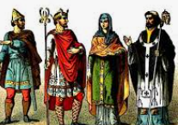
DT – Eating Seasonally  -Where does my food come from?  -Understand the advantages of eating seasonal fruit and vegetables  -Design, make and evaluate own recipe using seasonal ingredients  https://www.bbc.co.uk/bitesize/articles/zb23p4j  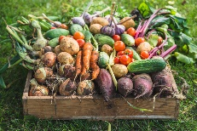 | Science  Y3/4 – Amazon rainforest to Antarctica  • Compare and group materials together, according to whether they are solids, liquids or gases  • Observe that some materials change state when they are heated or cooled, and measure or research the temperature at  which this happens in degrees Celsius  • Identify the part played by evaporation and condensation in the water cycle and associate the rate of evaporation with  temperature.  • Recognise that living things can be grouped in a variety of ways.  • Explore and use classification keys to help group, identify and name a variety of things in their local and wider  environment.  • Recognise that environments can change and that this can sometimes pose dangers to living things.  • Construct and interpret a variety of food chains, identifying producers, predators and prey  Year 3 Year 3 Science - BBC Bitesize  Year 4 Year 4 Science - BBC Bitesize  . | Modern Foreign Language – Spanish  Instruments  Shapes
Religious Education – What do Hindus believe that God is like?    Learn about:  -Brahman / Aum  -Trimurti  Shiva - transformer  Brahma – creator  Vishnu – sustainer/ protector  https://www.bbc.co.uk/bitesize/topics/zh86n39  https://www.bbc.co.uk/teach/class-clips-video/articles/zfvkhbk | Computing  Y5/6  Introduction to spread sheets / Data  Logging | PSHE - Y5/6    Keeping Safe  Understanding emotional needs, Staying safe online Drugs: norms and risks (including the law)  Rights and Respect  Rights, respect and duties relating to my health, Making a difference, Decisions about lending, borrowing and spending
 | Y3/4  Photo Editing / Variables in games Scratch | PSHE – Yr 3/ 4  Keeping Safe  Managing risk  Decision-making skills  Drugs and their risks  Staying safe online  Rights and Respect  Skills we need to develop as we grow up,Helping and being helped,Looking after the environment, Managing money
PE  PE is on a Monday and Wednesday.  Dance and Fencing  Striking and Fielding / OAA | Music  Y5/6 ‘I’ve been to Harlem’ – investigating pitch shape, ostinato, round, pentatonic, call-and-response, progression snapshot 1. | Art – Making monotypes  Understand that a monotype is a process where imaged are made by transferring ink from one surface to another to make a single print.  Combine monotypes with other disciplines such as a painting and collage.
 | Y3/4 ‘Chilled our clap rap’ – investigating beat, rhythm, dynamics, crotchet, paired quavers, notes C-D-E, crotchet rest.
Homework

Reading – We would love your child to read daily. Please sign your child’s reading record every time they read. (30 reads allow a day of non-school uniform!)

Times Table Rockstars
Home learning grids

Many Thanks, Miss Kinver and Mrs Davies

