Boyton Primary School - Autumn Term 2024
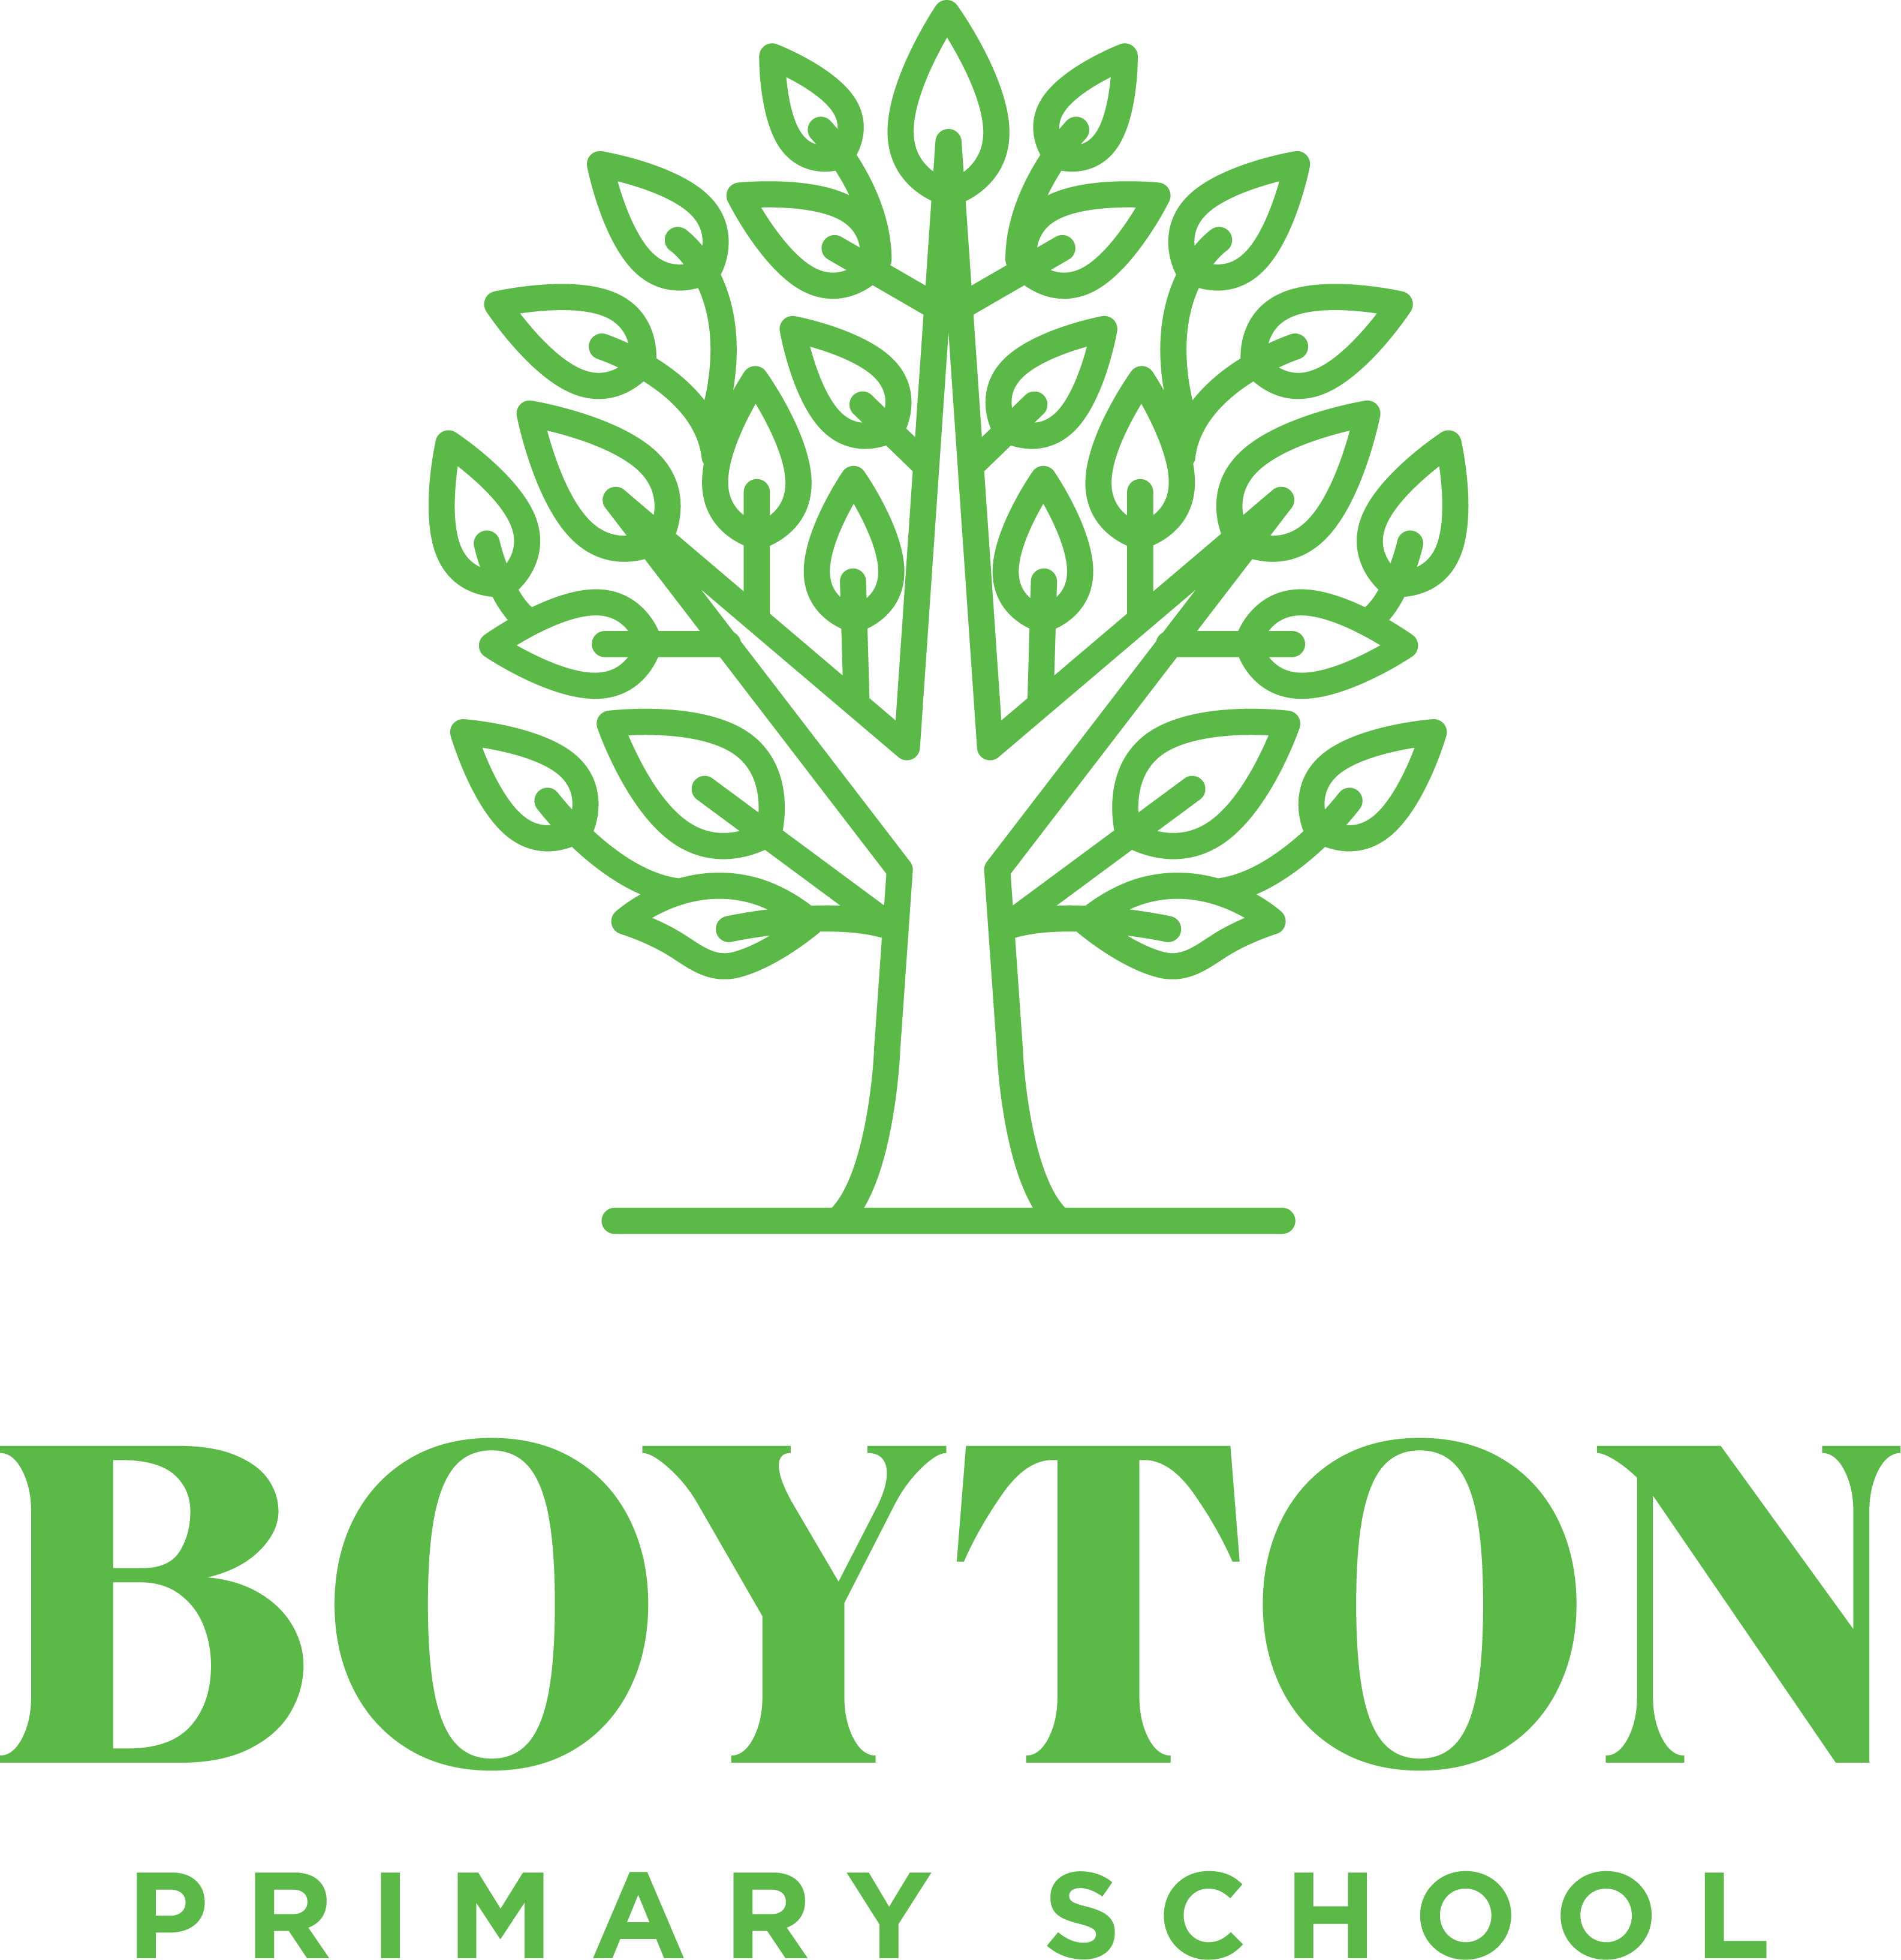
Chestnuts - Our Autumn Term Curriculum
This term, we have some great areas of learning. Please encourage your child to share any research they may do at home. For more detail, check the curriculum resources on the school website.
Writing  The Midnight Panther - Reports, poems, summaries, an own version narrative  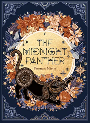  The Matchbox Diary -Biography Dialogue, diary entries, autobiography  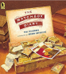  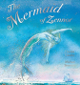  The Mermaid of Zennor – legends, information booklets,  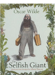  The Selfish Giant - own version narratives about kindness. Letters, first person recounts  https://www.bbc.co.uk/bitesize/topics/zwwp8mn https://www.bbc.co.uk/bitesize/subjects/zv48q6f | Reading – developing reading fluency, extending vocabulary and developing skills in prediction, retrieval, explanation, summary, sequence, inference.  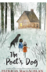  The Poet’s dog  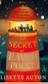  The Secret of Haven Point    Annie Lumsden, The Girl from the Sea  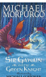  Sir Gawain and the Green Knight | Maths  Place Value - ordering, comparing, partitioning, rounding, Roman Numerals  (Y3 – numbers to 1000,Y4 – numbers to 10,000, Y5 – numbers to 1,000,000, Y6 – numbers to 10,000,000  Addition and subtraction – Y3 up to 3 digits, Y4 up to 4 digits, Y5 more than 4 digits, Y6 add/ subtract integers  Multiplication and division  Y3 multiples of 2,5,10,3,4 and 8  Y4 multiples of 3, 6, 9, 7, 11 and 12  Y5 multiples/ common multiples, factors, common factors, prime/square/ cube numbers, X/÷10, 100, 1000  Y6 multiples/ common multiples, factors, common factors, prime/square/ cube numbers, X/÷10, 100, 1000  Multiply/ divide - 4 digit by a 2 digit number
Geography – Why are mountains so important?  Using a geographical enquiry approach to investigate :  Definition of a mountain    Famous mountains – Mount Everest, Mauna Kea (volcanic), Mount Olympus(on planet Mars)  The Earth’s crust / plates – earthquakes/ volcanoes / fold mountains.  Famous explorers – Mallory and Irvine, Hillary and Norgay  Comparing Cambrian mountains to the Himalayan which are very different due to age. | Science  Y5/6 – Light and Electricity (Bright sparks)  Use the idea that light travels in straight lines to explain that objects are seen because they give out or reflect light into the eye  Explain that we see things because light travels from light sources to our eyes or from light sources to objects and then to our eyes  Use the idea that light travels in straight lines to explain why shadows have the same shape as the objects that cast them.  To compare and give reasons for variations in how components function, including the brightness of bulbs, the loudness of buzzers and the on/off position of switches.  Associate the brightness of a lamp or the volume of a buzzer with the number and voltage of cells used in the circuit  Compare and give reasons for variations in how components function, including the brightness of bulbs, the loudness of buzzers and the on/off position of switches | History - How did the Romans change Britain?  Empire – a term used to describe a group of territories ruled by a single ruler or state.  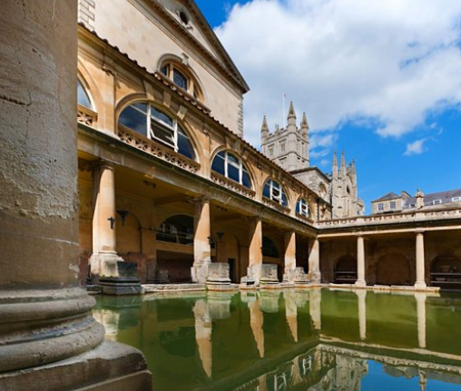  Key facts  - Why the Romans wanted to invade Britain.  - Boudicca and her revenge the construction of Hadrian’s wall  - Features of Roman towns in Britain.  https://www.bbc.co.uk/bitesize/topics/zqtf34j  https://www.bbc.co.uk/bitesize/topics/zwmpfg8 https://www.youtube.com/watch?v=oDIYw4eJJyI
DT – Textiles  Designing, making and evaluating stuffed toys using reused fabrics.  Developing skills in sewing – using blanket stitch, appliqué or decorative stitching to decorate the front of their stuffed toy.  Identify what worked well and areas for improvement.  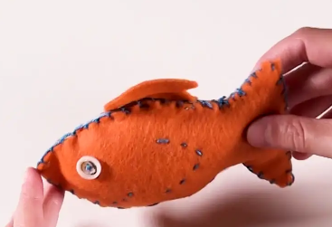 | Science  Y3/4 – Animals including humans (Amazing Human Body)  To identify that humans and some other animals have skeletons and muscles for support, protection and movement.  To identify that animals, including humans, need the right types and amount of nutrition, and that they cannot make their own food; they get nutrition from what they eat.  To describe the simple functions of the digestive system in humans  To identify different teeth in humans and name their functions  To know how top keep my teeth healthy  To construct and interpret a variety of food chains identifying producers, predators and prey by examining animal faeces. | Y3/4 Modern Foreign Languages  Phonics 1& 2 / Instruments  Seasons  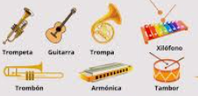
Y5/6 Modern Foreign Languages
Phonics 3 & 4 / The Date
Do you have a pet?
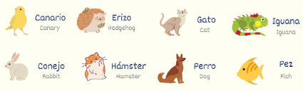
Religious Education  Creation and science: conflicting or complementary? [Creation]    What does it mean to be a Muslim in Britain today?   | Computing  Y5/6 Internet communication / webpage creation   | PSHE - Y5/6    Me and my relationships  Feelings / Friendship skills, including compromise / Assertive skills  Cooperation / Recognising emotional needs  Valuing difference  Recognising and celebrating difference Recognising and reflecting on prejudice-based bullying / Understanding Bystander behaviour / Gender stereotyping
 | Y3/4 The Internet, audio production   | PSHE - Y3/4  Me and my relationships  Healthy relationships / Listening to feelings  Bullying / Assertive skills  Valuing difference  Recognising and respecting diversity  Being respectful and tolerant / My community
PE  PE is on a Monday and Wednesday.  Tag Rugby / Netball  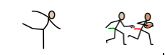  Gymnastics / Swimming (tbc) | Music  Y5/6 ‘I’ve been to Harlem’ – investigating pitch shape, ostinato, round, pentatonic, call-and-response, progression snapshot 1. | Art – Exploring Identity  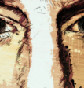  Discover how artists use layers and juxtaposition to create artwork which explores identity. Make our own layered portrait exploring paint, surface and texture.
 | Y3/4 ‘Chilled our clap rap’ – investigating beat, rhythm, dynamics, crotchet, paired quavers, notes C-D-E, crotchet rest.
Homework

Reading – We would love your child to read daily. Please sign your child’s reading record every time they read. (30 reads allow a day of non-school uniform!)
Spellings – These will come home every Tuesday. Please practice them in preparation for a test on a Monday.
Times Table – A range of questions up to 12 x 12 and TTRS

Many Thanks, Miss Kinver and Mrs Davies

