Music Development Plan
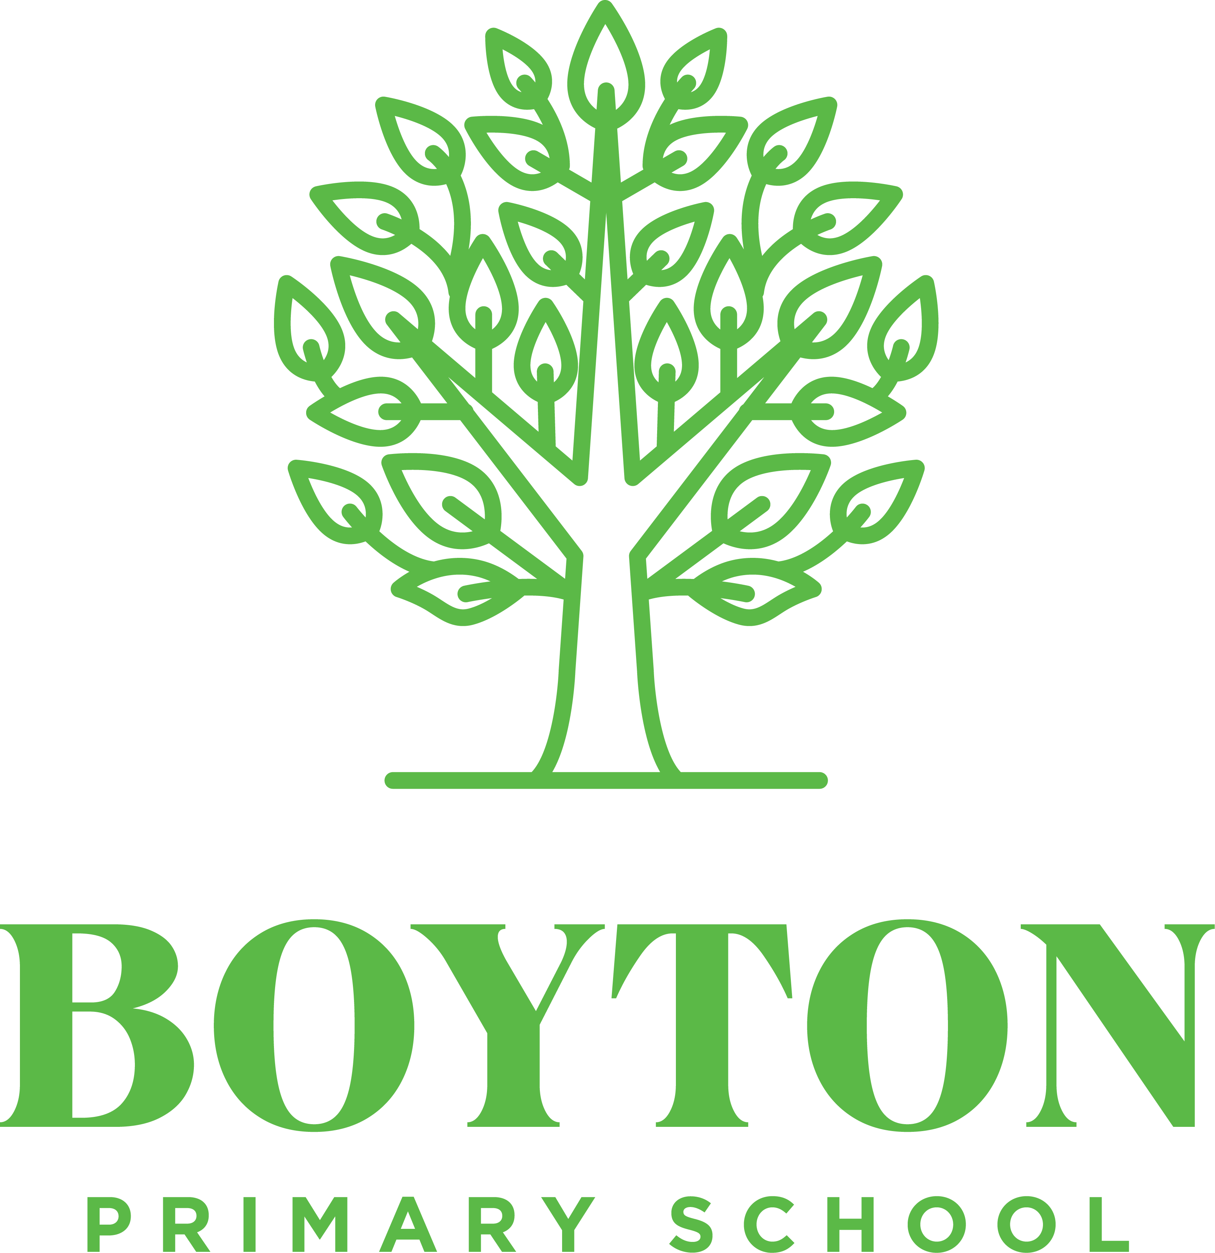
School: Boyton Primary School
Trust: TDAT
Local Music hub: ASONE
Music Lead: K Davies
Head of School: K Davies

Date written: January 2024
Updated: July 2025
Review: July 2025

1. Overall objective | Pupils leave Boyton Primary School having developed a love of music and an understanding of how to make music.  Pupils develop a life-long love of music. They’re given the opportunities to experience a high quality range of recorded and live music and learn to play a range of instruments including the voice with increasing skill and confidence.
2. Key Components | List of key components that makes up the Music curriculum in school  - Music curriculum, singing and instrumental teaching – EYFS, KS1, KS2, SEND  - Promotion of peripatetic lessons  - Links with ASONE hub  - Links with community music groups such as Launceston Town Band  - Performance Opportunities – Songfest, St Piran’s Event, Christmas performances, end of Year performance  - Whole school singing assemblies  13.7.24 Music continues to be taught by Mr Harrison. Children are receiving weekly high quality music lessons.  Efforts have been made to promote peripatetic lessons – but no children/ parents have responded yet.  It has proven challenging to participate in performance opportunities this year due to complexities around staffing. The updated hub model in September should ease this and efforts to perform with others will be prioritized.
3.Classroom Instrumental teaching | Use of First Access scheme from ASONE hub to provide fully funded, whole class instrumental teaching for KS2. (includes a variety of instruments such as brass, ukulele, keyboard)  Use of pitched/ unpitched in EYFS/KS1/KS2  13.7.24 Contact has been made with ASONE regarding peripatetic music lessons and information shared with parents. At this stage, no parents/ children have expressed interest to pursue this further.  Action – to follow this up in new academic year.
4. Implementation of key components | School has a rolling programme of themes covered within the Sing-Up curriculum.  Assessment is conducted by recording audio/ video at the beginning and end of each unit. (With notes re specific successes and areas to develop)  Singing assemblies to prepare pupils for performance
5. Communication Activities | Parents informed of musical opportunities through school newsletter.  Photos/ recordings of performance available to parents/ carers on social media where possible.
6. Evaluation of process for the success of the Music Development Plan | Half termly review – what is working?/ what are our successes/ what needs more support/ where is the support available from/ what changes need making?
7. Transition work with local secondary schools | Links have been made with Launceston College regarding possible music opportunities for our KS2 children.
8. Budget, Materials and Staffing | Annual subscription to Mr Harrison – Big Bang Music. This provides bespoke provision – high quality teaching from an experienced professional and resourcing of lessons.  Songfest Entry - £24  Primary Engagement Lead ASONE hub
9. Pupil premium and SEND | Quality first teaching for all pupils  Subsidies available for pupil premium pupils who engage with peripatetic lessons
10. Summary Action plan | See attached.

