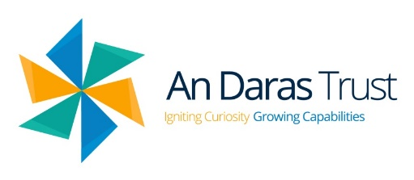**An Daras Trust – Sustainability Charter**

***Sustainability (n):*** The property of being environmentally sustainable; the degree to which a process or enterprise is able to be maintained or continued while avoiding the long-term depletion of natural resources

**Who is this charter for?**

Everyone in & around the An Daras Trust: pupils, employees, families, community.

**An Daras Trust commits to:**

* Educate our pupils, through the national curriculum and within their school life, to develop an understanding of the world and the natural environment
* Provide a diverse & wealth of opportunities for our pupils to have ‘hands on’ & real-life experiences to reinforce their learning
* Empower our pupils & employees to make sustainably friendly decisions confidently
* Promote sustainability in all our sites and within the community
* Adopt sustainable practices wherever possible
* Ensure all decisions around managing premises, purchasing goods/services, managing resources & waste, take into account the impact on environment

**An Daras Trust pledges to:**

* Embed sustainability across the curriculum
* Significantly reduce food & general waste
* Reduce energy consumption
* Increase re-wilding & biodiversity on Trust sites
* Encourage active ways of travelling: walking, cycling & public transport
* Use purchasing power to favour sustainable & ethical products & services
* Ensuring employees lead by example